top end lodge adventure

5 days (self drive)

WILDMAN WILDERNESS LODGE AND CICADA LODGE
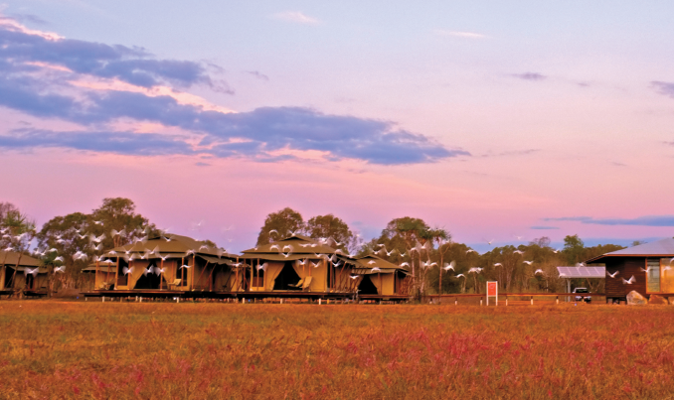

Day 1
Depart Darwin accommodation for drive to Wildman Wilderness Lodge.
Wildman is located approximately half way between Darwin and Kakadu, 170km by road from Darwin City. Drive time from Darwin is less than two hours, along the sealed Arnhem Highway. (For those who don't wish to self-drive, Wildman Wilderness Lodge offers a door to door transfer from Darwin hotels and airport. Departing daily on request, the transfer departs Darwin at 2pm, arriving at Wildman Wilderness Lodge at 4pm).
Stop off at Adelaide River for a chance to see the Jumping Crocodiles for which this area is famous.
Amidst the lush wilderness of Australia's breathtaking Top End, Wildman Wilderness Lodge offers an extraordinary wetlands safari experience, situated in the Mary River Wetlands area half way between Darwin and Kakadu National Park. Wildman is a small-scale, high quality safari lodge featuring a variety of boutique and environmentally sensitive accommodation and touring options.
Overnight Wildman Wilderness Lodge (L, D)
Day 2
Full day Kakadu tour - Our Kakadu day tour gets an early start, departing the Lodge at 8:00am to travel along the Arnhem Highway to the world famous Kakadu National Park. You'll visit all the major highlights before returning to Wildman at approx. 5:00pm.
Overnight Wildman Wilderness Lodge (B, L, D)
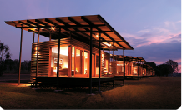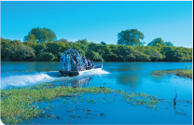
Day 3
Morning Home Billabong cruise - Enjoy a one hour cruise on Home Billabong as the sun warms up and nature comes to life. You are likely to glide past prehistoric looking crocodiles, an amazing array of birdlife and an abundance of wildflowers. It is an ever changing living ecosystem which is both beautiful and fascinating. Every cruise is different and offers a unique experience.
Depart Wildman for drive through Kakadu to Cicada Lodge in Katherine - approx. time 4 hours.
Cicada Lodge, is your sanctuary from which to embrace the ancient landscapes and indigenous culture within the iconic Nitmiluk National Park. The Lodge is a joint venture between the Jawoyn people and Indigenous Business Australia (IBA), and the perfect base to explore Nitmiluk Gorge and the National Park.
Overnight Cicada Lodge: (sunset canapés and dinner)
Day 4
Take advantage of the morning light for a 1.5 hour Adventure Swim helicopter tour. Fly over the 13 gorges of the Nitmiluk system and land at a remote waterhole. Just you and your guests and the serenity of your own pristine swimming hole - crystal clear waters and not a sole to disturb the peace.
Relax poolside before heading off for the Nabilil Dreaming Sunset dinner cruise. Sit back and relax as the tranquil surroundings transport you into a spiritual world of the Jawoyn culture and history. Discover the stories and ways of the Jawoyn people against the magnificent backdrop of the Nitmiluk Gorge, changing colour with the setting sun. Experience the spectacular beauty of the Gorge by candlelight and starlight whilst enjoying delicious Australian cuisine.
Overnight Cicada Lodge (B, D)
Day 5
Depart Cicada Lodge for 3 hour return drive to Darwin along Stuart Highway. You may wish to explore the waterfalls at Litchfield National Park on the way back.
