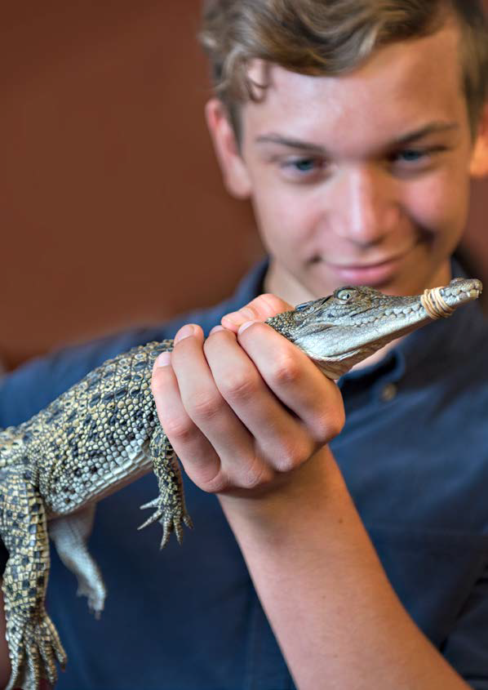

NT LEARNING
ADVENTURES
INTRODUCTION
Welcome to the Northern Territory - a place of discovery, rich in history and Aboriginal culture, and home to inspiring and fulfilling educational experiences. Recognising that a hands-on experience is the best learning tool, the Northern Territory government's tourism body, Tourism NT, has worked with tourism operators, National Parks, attractions and the education department to create 'NT Learning Adventures'.
'NT Learning Adventures' is made up of tourism providers offering products specifically for the education Study Tour market. This allows educators, agents and families to choose the best education options for their students.
The Northern Territory is full of inspiring educational destinations and experiences to explore. It is a vast area, home to World Heritage areas, National Parks and abundant wildlife. The NT offers stimulating outdoor activities with focuses including sustainability, ancient Geology, rich Aboriginal culture and important historic events of the NT and Australia. Our close proximity to Asia allows for effortless international travel and opens up many learning opportunities focused on Asian engagement.
We all know the ideal classroom is one that you can have outdoors. Read on to learn more about the adventurous and exciting destinations and attractions available throughout the Northern Territory; a truly captivating part of Australia.

HOW TO ARRANGE YOUR NT LEARNING ADVENTURE
Option 1 – Outsource. Contact an operator (see page 45) to coordinate your custom itinerary (may include; accommodation, activities, educational resources and transfers/ transport).
Option 2 – Do it yourself. Follow one of the example itineraries in this publication or design your own tour using the NT Learning Adventures providers in your region of choice, coordinating your own travel arrangements.
Option 3 – Contact StudyNT. If you are looking to visit one of the Northern Territory’s world class international education and training providers during your visit, please contact studynt.nt.gov.au.
If you require further assistance, please contact Tourism NT via the northernterritory.com/find-out-more/contact-us page. Please use ‘Education Tours’ as the subject line.

Contents
Alice Springs - Learning Adventures 6
Uluru-Kata Tjuta National Park Learning Adventures 12
Tennant Creek - Learning Adventures 18
Central Australian Learning Institutions & Accommodation 19
Central Australia Suggested Itineraries 21
Katherine Region - Learning Adventures 23
Kakadu National Park - Learning Adventures 27
Arnhem Land - Learning Adventures 29
Darwin Region - Learning Adventures 31
Darwin & Top End Learning Institutions & Accommodation 41
Darwin and the Top End Suggested Itineraries 43
Operators Who Can Make Arrangements for Your NT Study Tour: 45
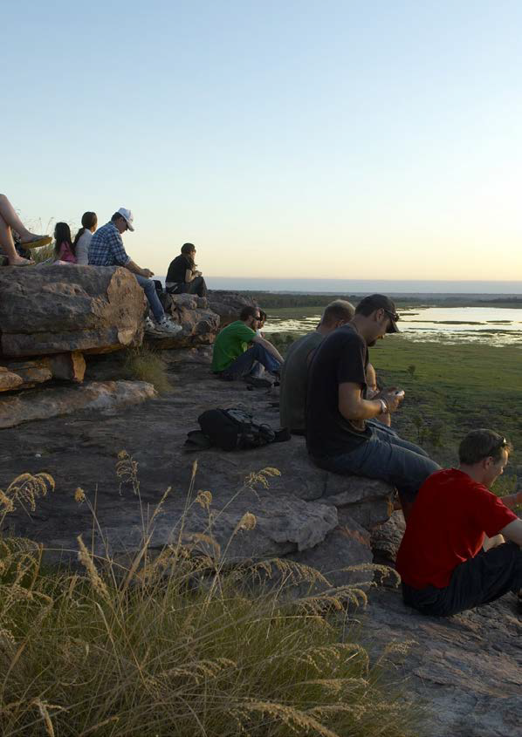

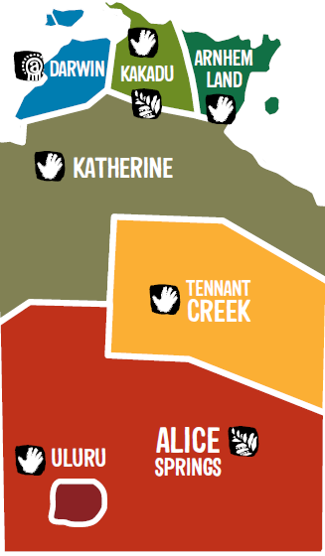
The Northern Territory is vast and full of inspiring and educational destinations and experiences. From the majesty of Uluru to the detailed rock art of Kakadu National Park. With the rich living culture of Australia's Aboriginal people, combined with the history of exploration, modern discoveries and the bustling vibrancy of modern towns, there are in-depth learning opportunities beckoning. World Heritage areas and National Parks offer stimulating outdoor activities with a focus on sustainability, culture and history. Darwin's geographical position spotlights Australia's close links with Asia, past and future.
This brochure contains suggested itineraries and locations using operators who are not only experts in their field, but have expressed a genuine interest in providing a stimulating, safe, learning environment for students of all ages. They are committed to working with organisers to provide personalised itineraries not only meeting educational requirements, but also ensuring memorable and enjoyable journeys.
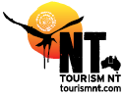
ntlearningAdventures.com
education.tourismnt@nt.gov.au

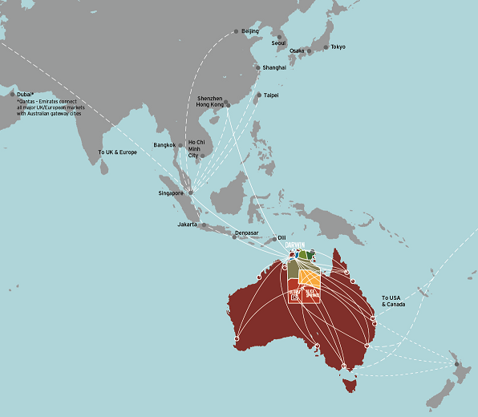

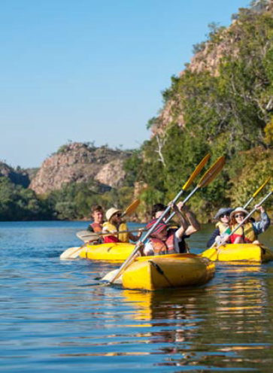
The tourism providers involved with NT Learning Adventures understand the
planning needs of teachers, educators and excursion organisers. Operators
are ready to help with all the information needed and can provide the
following applicable elements:
- Risk assessments for all excursion activities
- Safety and security on educational excursions
- Opportunity to engage with remote Aboriginal communities
- Assistance with developing sister-school relationships
- Flexible Learning Adventures to suit students' needs
- Student and teacher resources (pre and post tour)
- 'Working with Children' cards
- Sustainability programs
- Cultural immersion programs
- 'Giving back' programs
- Sample itineraries.

Alice Springs - Learning Adventures
The quintessential outback town of Alice Springs, located in the heart of Australia's outback offers an excellent variety of adventurous education excursions that fulfil a range of learning outcomes.
Central Australia has a true desert climate. Clear sunny days with cold winter nights and little rain make for interesting flora and fauna in the area. Visit Earth Sanctuary and the Solar Centre Desert Knowledge for real examples of hands-on learning about the land, climate and sustainability.
Alice Springs has an extensive history of settlement and exploration, from the traditional Arrernte Aboriginal people of the area through to European adventurers, pioneers and current residents. The area's significant historical events and cultural influences have contributed much to the nation and provide valuable learning experiences for students of all ages.
Visiting the Alice Springs Telegraph Station Historical Reserve, the Pioneer Women's Hall of Fame, Alice Springs School of the Air and the Royal Flying Doctor Tourist Facility as well as Aboriginal significant sites of interest bring the past to life in a very real sense. Alice Springs Desert Park showcases arid flora and fauna, bush tucker and wildlife in an environmental education facility. There's much to offer in the town with a wide range of Aboriginal art, history, cultural events and festivals.
An excursion to the Alice Springs region will give students a greater understanding of the country around them and how the environment has shaped lifestyles and culture. Interaction with the area's Aboriginal people introduces cultural perspectives of land and the connections between plants, animals, people and landscapes.
Travel to Alice Springs by either plane, train or bus and choose to explore just the town itself, or go beyond and visit other significant geological areas such as the East and West MacDonnell Ranges, Kings Canyon (Watarrka National Park) and Uluru.
For information about parks, reserves and wildlife in the Alice Springs region, contact NT Parks and Wildlife's Alice Springs office on +61 (0)8 8951 8250 or visit: parksandwildlife.nt.gov.au
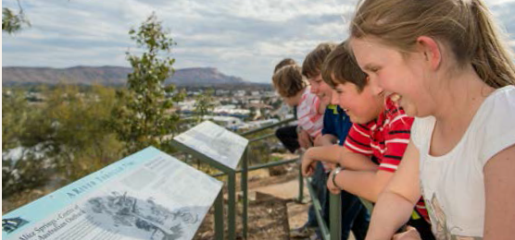

Earth Sanctuary
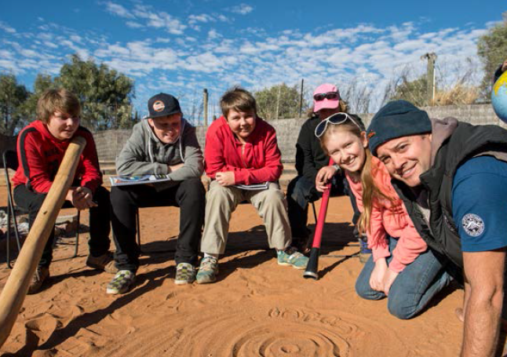

Earth Sanctuary
Lot 4005 Colonel Rose Dr,
Alice Springs NT
+61 (0)8 8953 6161
earthsanctuary.tours@gmail.com
earth-sanctuary.com.au
Earth Sanctuary World Nature Centre is an award-winning 'sustainable living environment' located 15 kilometres south of Alice Springs overlooking the East MacDonnell Ranges.
For the last 15 years, this family-owned and run business has been offering experiences that focus on ecology, culture, astronomy and sustainable living practices. Earth Sanctuary holds Advanced Ecotourism Accreditation and is specifically dedicated to schools and environmentally conscious travellers.
The display centre integrates six categories to help visitors become more sustainable—energy, water, food, utilities, shelter and wellbeing. From solar and wind farms to geodesic domes, your students will learn how all these elements have been actioned at the sanctuary and will leave with the skills to develop their own sustainable living practices when they get home.
Earth Sanctuary also offers interactive cultural experiences such as spear throwing, bush tucker, tracking and Indigenous art, and students will come away with an overall appreciation for Indigenous survival and sustainability.
There are full camping facilities for small and large groups and half-day, full-day or extended touring options. Our professional and passionate guides are experienced in education and can tailor subjects to your curriculum needs. Our team is fully trained in first aid—many are paramedics— and all guides obtain a Working with Children permit.

RT Tours Australia
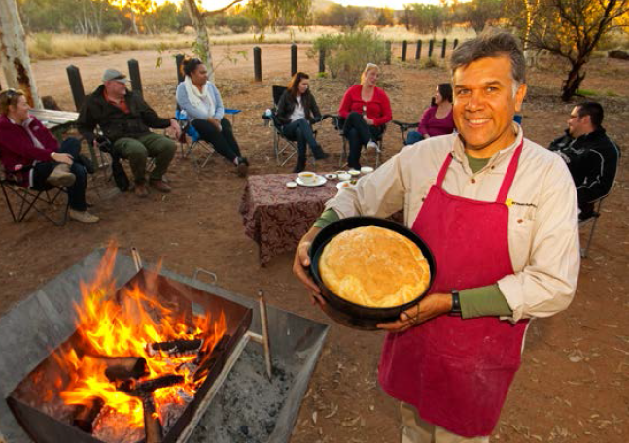
RT Tours Australia
Alice Springs NT
+61 (0)8 8952 0327
bob@rttoursaustralia.com
rttoursaustralia.com.au
Join Bob Taylor, a renowned Indigenous chef and tour guide, on a journey of food, culture and country in Central Australia.
RT Tours Australia is a national, award-winning tourism operator that offers specialised touring options for students. Tours cover elements including Australian history, geography and Aboriginal culture. Students will learn about Aboriginal history and culture from local Aboriginal people and gain an understanding about what it is to be an Indigenous person in modern Australia
You can choose from a range of touring options, from day tours to extended camping tours to Uluru. Depending on what your students need to achieve from the excursion, we can meet your requirements, educationally and logistically.
Our lunch and dinner tour focusses on bush food, Aboriginal culture and Dreamtime and how these have adapted since white settlement. After bush food demonstrations and sampling, you and your students will help prepare a delicious meal cooked in the bush barbecue setting.
Our extended tours are all customised to suit your needs and provide a greater mixture of the above along with visiting iconic Central Australian locations such as Mt Connor, Kata Tjuta and Uluru.

Alice Springs Desert Park
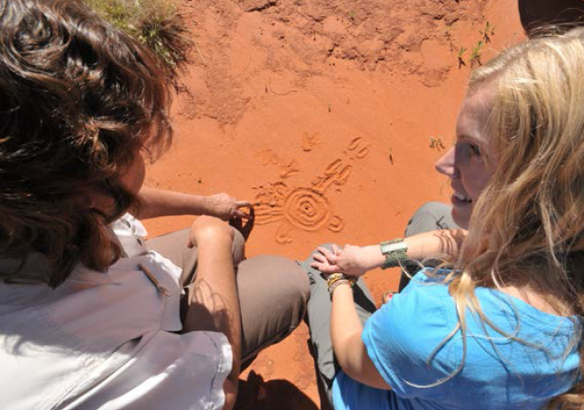
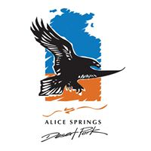
Alice Springs
Desert Park
Larapinta Drive, Alice Springs NT
+61 (0)8 8951 8788
asdp@nt.gov.au
alicespringsdesertpark.com.au
The Alice Springs Desert Park is a government-owned, purpose-built facility that brings the Central Australian desert to life.
Students will gain an understanding that the country around them is ancient, alive, exciting and dynamic. They'll learn about the connection between desert plants, people, landscapes and culture.
The Desert Park offers guided and self-guided tour programs for students in the areas of biology, ecology, flora and fauna and history— all specific to Central Australia.
On a cultural tour, students will learn how it's possible to survive in a desert and hear the survival stories of desert people. They'll walk through the local people's ancient supermarket, hardware shop and pharmacy. It's these experiences that will inspire the students to find answers themselves, presenting the challenge of research skills, creative thinking, personal interpretation and a general understanding of the area.
At night, students can learn about rare and endangered animals of Central Australia on the very popular Nocturnal Tour. Don a head lamp and step into the Mulga Walk, a large predator-proof enclosure, and see bilbies foraging, come centimetres from an echidna and, if you're lucky, spot Mala now only found in captivity on the mainland.

Did you know?
Alice Springs is one of Australia's solar cities.
Find teacher resources here: alicesolarcitu.com.au

Remote Tours NT
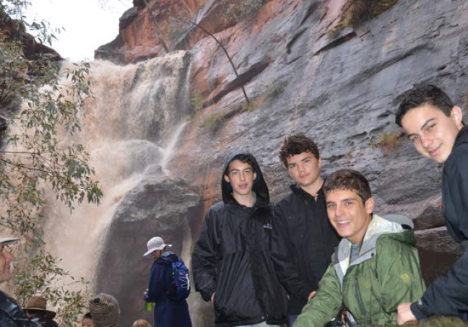
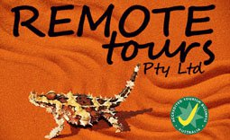
Remote Tours NT
Alice Springs NT
+61 (0)8 8953 7012
reg@remotetours.com.au
remotetours.com.au
Remote Education Tours gives students the opportunity to meet and interact with Indigenous locals, stay as guests on their traditional lands and participate in cultural activities.
Remote Education Tours offers school excursions that focus on culture and community development in Central Australia. Students can support the communities they visit by participating in local development projects such as building vegetable gardens, general landscaping duties and maintenance on buildings. Projects will depend on the students' age, time of year and community need at the time. Our excursions encourage lessons in life skills, awareness of different cultures and giving back to the land and people you visit. This is much more than just a tour; it's a chance to discover a connection to the land and its people that will stay with you for a lifetime.
We are an accredited company with more than 20 years' experience in Central Australia. Our staff have Working with Children permits, first aid and tour guide certifications.
We specialise in school and education groups of 12 or more, with trips ranging from five to 10 days, or tailor made to suit your learning objectives or school calendar.

Did you know?
The East and West MacDonnell ranges of Central Australia hold many culturally significant sites and ancient stories for the local Arrernte Aboriginal people.

Alice Springs Telegraph Station Historical Reserve and Outback Cycling
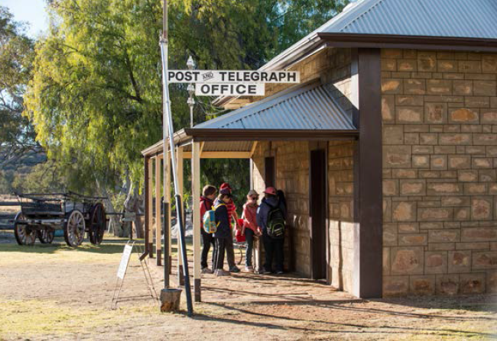
Alice Springs Telegraph Station Historical Reserve and
Outback Cycling
Herbert Heritage Drive,
Alice Springs NT
+61 (0)8 8952 3993
trailstation@outbackgroupnt.com.au
alicespringstelegraphstation.com.au
The Alice Springs Telegraph Station Historical Reserve is a must-do for education groups visiting Alice Springs. The reserve marks the original site of the first European settlement in Alice Springs. Built in 1872, the Telegraph Station ran for 60 years and has since had a variety of uses, including as an Aboriginal school and 'the bungalow' for Aboriginal children and an army staging post during WWII.
The local history on show at the precinct is wide and varied, including interpretive displays of the first explorers coming through inland Australia. Through the displays and artefacts at the station, including the well-preserved building, students will learn about Australian history. Tours are offered all year and can be tailored to students' needs to meet curriculum objectives or other requirements.
Outback Cycling offer bicycle hire from the Alice Springs CBD shop and guided mountain bike tours from the Telegraph Station. Our bicycle hire includes bike, helmet and bike lock. Guided mountain bike tours cater for all levels, from easy riding to more advanced tracks. These tours can include commentary on local information, geology of the region, plants and geography. See outbackcycling.com for further information.

Uluru-Kata Tjuta National Park Learning Adventures

Uluru-Kata Tjuta National Park is internationally recognised as a World Heritage listed area for both outstanding natural and cultural values.
The park is on Aboriginal land and jointly managed by the Australian Government and Anangu traditional owners. Anangu welcome all visitors to the park to learn about the living cultural landscape, including Tjukurpa (law, creation stories, and beliefs), Pitjantjatjara (the local language), inma (traditional song and dance), tools and weapons, bush tucker and more.
Learn about the unique geological formations of Uluru and Kata Tjuta, which geologists believe began some 550 million years ago. Join in on a hands-on Aboriginal experience with either Maruku or Uluru Aboriginal Tours, or venture out with SEIT Outback Australia to explore other traditional Aboriginal areas such as Cave Hill and Mt Connor.
Uluru-Kata Tjuta National Park rangers run specialised presentations focussed on learning outcomes for students. Arrangements can be made for education group entry passes along with a variety of teaching resources. Students can engage with park rangers on presentations covering relatable subject areas such as history, culture and nature including geology, flora and fauna pertinent to this area. The education and interpretation officers at the park hold Working with Children cards.
It is important that visitors to the park respect both country and culture. The best way to do this is to choose not to climb Uluru, take only memories and leave only footprints!
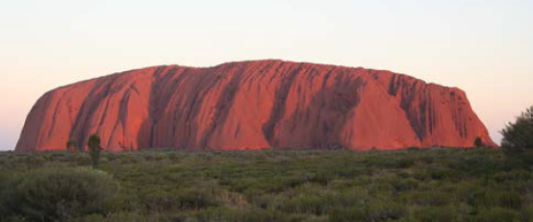
Flights are available from capital cities direct to Uluru (Yulara), along with regular flights from Alice Springs. The 450km journey by road from Alice Springs to Uluru-Kata Tjuta National Park is an extraordinary one, allowing students to explore the geological formations as well as gain an understanding of the characteristics of the changing environment of the region.

For information on Uluru-Kata Tjuta National Park
please call
+61 (0)8 8956 1128 or email uluru.education@
environment.gov.au
www.environment.gov.au/topics/national-parks/uluru-kata-tjuta-national-park/education

Uluru Camel Tours
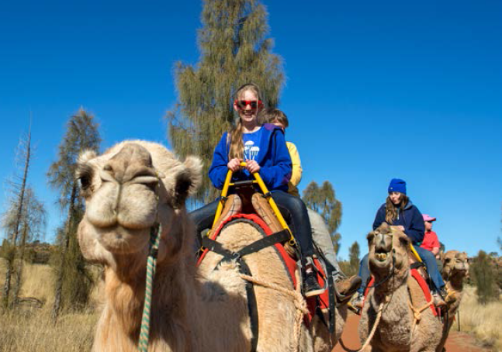
Uluru Camel Tours
Town Square, Ayres Rock
Resort, Yulara NT
+61 (0)8 8956 3333
reservations@
ulurucameltours.com.au
ulurucameltours.com.au
Uluru Camel Tours is Australia's largest camel farm with more than 50 working camels. Your students will enjoy a fun and interactive experience with us.
After a camel ride, they can wander through our saddlery where we hand-make our own saddles from scratch using original antique saddler tools and methods.
They'll meet our outback cameleers, hear their stories and learn the history behind some of Australia's greatest and bravest explorers, pioneers, Afghan cameleers, ANZAC cameleers and Aboriginals.
We cater for children 10-18 years old and large group sizes, and we can customise excursions to align with your organisations current studies.
Our farm has a fully equipped barbecue area and seating for up to 100 people, we invite you to use these facilities while touring with us.

Did you know?
Cameleers played an important role in the early history of exploration of Central Australia.

SEIT Outback Australia
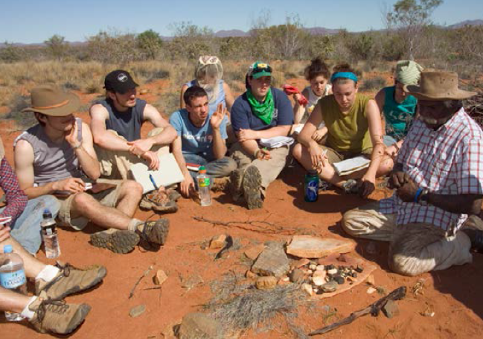
SEIT Outback Australia
Yulara Dr, Yulara NT
+61 (0)8 8956 3156
bookings@seitoutbackaustralia.com.au
seitoutbackaustralia.com.au
SEIT Outback Australia provides cultural immersion experiential learning programs in the Red Centre aimed at inspiring students and providing life skills for future development.
SEIT Outback Australia has been coordinating school programs for more than ten years and has constructed flexible itineraries comprised of a number of easily interchangeable components designed to fit with your school's requirements.
SEIT Outback Australia in partnership with the Anangu custodians of the Aboriginal Lands invite students to participate in a rare and empowering opportunity to immerse themselves in a culture older than time to experience and understand traditional Aboriginal people.
On your journey you will experience:
- Visit the heritage listed Uluru-Kata Tjuta National Park
- Learn about Tjukurpa - the creation stories and law of Aboriginal Culture
- Experience how song and dance are used to teach in Aboriginal Culture
- Discover a new form of education, teaching and learning with Aboriginal school friends
- Collect and eat bush foods
- Hear about the geology, flora and fauna of the region
- Sleep under the stars in remote Australia
- Sit around the campfire with your Anangu hosts to share life stories
Join an Aboriginal cultural immersion program that will connect students with country, culture and the environment. Whether it's a five, nine or ten-day camping experience or a one-day featured adventure, your students will enjoy the journey and take with them a greater understanding of all that is Central Australian.
SEIT Outback Australia can provide all camping equipment and offers exclusive and private camping sites across the Red Centre region.

Maruku @ Uluru
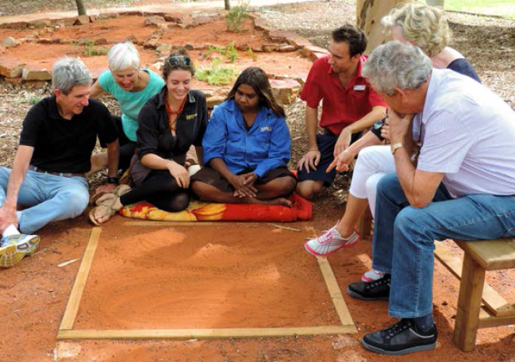
Maruku @ Uluru
Uluru-Kata Tjuta National Park, NT
0499 829 635
dotpainting@maruku.com.au
maruku.com.au
At Maruku Arts near Uluru, students can join a hands-on workshop with traditional Aboriginal artists and create their own artwork. They'll join an information session about the culture of the desert and the meaning of some of the icons of the region, including the animals, the landscape and a background to the stories of Uluru and Kata Tjuta.
At Maruku, sharing our stories and passing on traditional methods of painting plays an important part in the sustainability of Aboriginal culture. Art plays a huge part in the history of Anangu, the traditional Aboriginal people of the desert.
Maruku is Aboriginal owned and all profits from the artworks go to the surrounding communities so that a strong culture is maintained and educational tours can continue.
We cater for a maximum of 40 students at any one time and partner with the rangers at Uluru-Kata Tjuta National Park to share information.

Did you know?
Uluru is estimated to be over 550 million years old, is 348 metres above ground and 2.5 kilometres below ground.

Austour
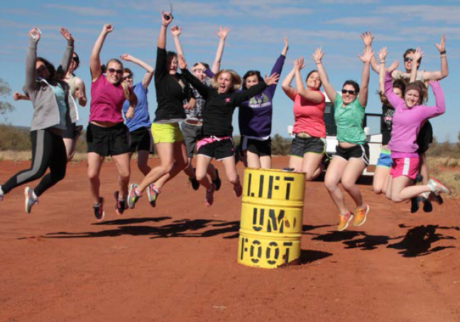
Austour
Frankston, VIC
+61 (0)3 9782 4959
austour@austour.com.au
austour.com.au
Austour is a touring company that offers specialist educational experiences in the Northern Territory. We offer programs from an introduction to Aboriginal culture to full immersion programs with schools in Central Australia, Darwin and the Top End and Arnhem Land.
A family owned company for more than 40 years, Austour has the experience, knowledge and contacts that can support and create excursions into the Northern Territory for students to further their learning in Aboriginal Studies, Earth and Environmental Studies, Community and Family Studies, Visual Art Studies, Primary Industry and Agricultural Studies.
Austour trips are comprehensive and can include specialist guides, accommodation, activities, meals and transport.
Austour is committed to providing service, experience and understanding and we are ready to support your school in developing a meaningful program.

Tennant Creek - Learning Adventures
Tennant Creek and the surrounding Barkly Region offer real insight and hands-on exploring for students to experience the 'real outback'. Synonymous with the cattle industry, the Tennant Creek region lies 500 km north of Alice Springs and 1000 km south of Darwin. Events and activities in the region had a marked influence on Australia's history. Discover the stories of early gold mining, how the cattle industry was established along with the culture of the traditional Aboriginal owners of the area, the Warumungu people.
The drive from Alice Springs to Darwin takes you on a historical journey, travelled first by the famous explorer, John McDouall Stuart, as well as covering the same 'corridor' as the Overland Telegraph, built as the main source of communication between Australia and England in the nineteenth century.
Tennant Creek showcases the Nyinkka Nyunyu Art and Culture Centre. This well-designed exhibition which showcases five major sections relating to Aboriginal culture through art including: family, living on the land, yesterday and today, returned histories and getting the land back. An interesting pedagogy, this formation of time will allow the students to discover a cultural perspective of Australian history.
Gold was discovered here in the 1930's, sparking Australia's last gold rush. Battery Hill Mining Centre offers specialised tours with dedicated guides. Whether students are researching the history of the gold rush, or their interests lie within the mining industry, the Centre will provide a learning opportunity for a range of interests. Just 3kms north of the town is the Mary Ann Dam, perfect for swimming and canoeing.
Visit a variety of interesting places along the way such as Barrow Creek Telegraph Station, Karlu Karlu/Devils Marbles Conservation Reserve, the Kelly West Meteorite Crater, Kelly's Ranch and much more.
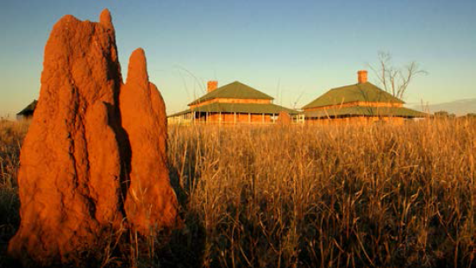

Central Australian Learning Institutions & Accommodation

Enhance Your Central Australian Education Experience
with a visit to these Learning Institutions:

Strehlow Research Centre
61 Larapinta Drive, Araluen NT
+61 (0)8 8951 1111
strehlow@nt.gov.au
artsandmuseums.nt.gov.au
National Pioneer Women’s Hall of Fame
2 Stuart Terrace, Alice Springs NT
+61 (0)8 8952 9006
operations@pioneerwomen.com.au
pioneerwomen.com.au
NT Parks and Wildlife
For general NT Parks information:
nt.gov.au/leisure/parks-reserves
+61 (0)8 89 518 250 (Alice Springs region)
For current NT Parks information:
facebook.com/ParksandWildlifeNT

Alice Springs School of the Air
80 Head Street, Alice Springs NT
+61 (0)8 8951 6834
visitorcentre@assoa.nt.edu.au
assoa.nt.edu.au
Royal Flying Doctor Service
8-10 Stuart Terrace, Alice Springs NT
+61 (0)8 8958 8411
reservations@flyingdoctor.net
rfdsalicesprings.com.au
Alice Springs Reptile Centre
9 Stuart Terrace, Alice Springs NT
+61 (0)8 8952 8900
enquiries@reptilecentre.com.au
reptilecentre.com.au

For more information contact:
Tourism Central Australia
Cnr of Todd Mall and Parsons Street,
Alice Springs NT
+61 (0)8 8952 5800
info@discoverca.com.au
discovercentralaustralia.com

Group Accommodation in Central Australia

Alice Springs
Aurora Heavitree Gap Outback Lodge
Palm Circuit, Alice Springs NT
+61 (0)8 8950 4444
res@htgol.auroraresorts.com.au
auroraresorts.com.au/aurora_Heavitree
Big 4 MacDonnell Range Holiday Park
Palm Pl, Ross Alice Springs NT
+61 (0)8 8952 6111
macrange@macrange.com.au
macrange.com.au

West MacDonnell Ranges
Glen Helen Resort
1 Namatjira Drive, Alice Springs NT
+61 (0)8 8956 7208
bookings@glenhelenlodge.com.au
glenhelenlodge.com.au

Uluru
Voyages Ayers Rock Campground
Yulara NT
+61 (0)8 8957 7001
campground@ayersrockresort.com.au
voyages.com.au

Kings Canyon
Kings Creek Station
Off Lasseter Highway, Kings Canyon NT
+61 (0)8 8956 7474
res@kingscreekstation.com.au
kingscreekstation.com.au
Kings Canyon Resort
Luritja Road, Kings Canyon,
Watarrka National Park NT
+61 (0)8 8956 7442
kcfront1@delaware.com
kingscanyonresort.com.au

Central Australia Suggested Itineraries

Sustainability and Culture of Alice Springs: 6 days
Day 1 - 2
Meet your tour guide/driver and transfer to Earth Sanctuary where you'll camp overnight and learn about ecology, sustainability and culture in Central Australia. The team here will captivate your students with hands-on activities, and students will gain skills and understanding on what they can do to help reduce their carbon footprint.
Day 3
Depart Earth Sanctuary and head into Alice Springs to visit some iconic locations such as:
- Alice Springs Desert Park
- Araluen Cultural Precinct
- Alice Springs Telegraph Station
Stay in Alice Springs for the next two nights.
Day 4-5
Spend the next two days exploring the West MacDonnell Ranges with Bob Taylor of RT Tours Australia. Bob is an Aboriginal guide and chef. Visit fascinating gorges, chasms, waterholes and ochre pits where Aboriginal people have been sourcing their painting materials for centuries. The main focus points for this tour will be food, culture and country.
Day 6
Depart Alice Springs.

Culture, Environment, History and Landscapes of Central Australia: 9 days
Day 1 - 2
Meet your guide at Alice Springs and transfer to your accommodation for two nights. While in Alice Springs, plan a visit to the following attractions for an insight into the history, culture and landscape of this area:
- Alice Springs Desert Park
- Alice Springs Telegraph Station
Day 3 - 5
Meet your new guide with SEIT Outback Australia and travel out to Kings Creek Station, where you'll stay for two nights. Take the breathtaking Kings Canyon Rim Walk early in the morning. Later, take a day trip to a local Aboriginal community and participate in a cultural learning session with some hands-on activities.
Day 6 - 8
Depart Kings Creek Station and head out to Cave Hill to learn about traditional Aboriginal people and how they live and share their Tjukurpa (creation) stories.
Afterwards, continue onto Uluru and settle into your camp. Take a quick walk to view the sun setting behind Uluru, a magical experience for people of all ages.
The next morning, take a sunrise camel ride. Camels played an important role in Australia's history, and Uluru Camel Tours offers interactive learning sessions specifically for students.
For the remaining time here, travel around Uluru-Kata Tjuta National Park. Join in cultural activities at the town square, a dot painting and cultural session with Maruku Arts and walk around the base of Uluru and through the domes of Kata Tjuta guided by a Parks Australia ranger.
Day 9
Depart Uluru.

Cultural immersion tours
For an in-depth cultural immersion program where students have access to Aboriginal communities, interaction with Aboriginal people and hands-on learning, we suggest the following operators:
- SEIT Outback Australia
- RT Tours Australia
- Remote Education Tours

Katherine Region - Learning Adventures
The Katherine region is the gateway to the north of the Northern Territory, known as the Top End. Its geological gorge formations, unique landscape, historical makeup and rich culture present a range of activities relevant to a variety of study preferences. Katherine is accessible by a 316km road trip from Darwin or as a continuation of a road journey from Alice Springs.
One of its greatest attractions is the assortment of national parks and reserves that cater to the needs of all groups, from the rugged and remote Limmen National Park in the east, through the vast cultural landscape of Nitmiluk and the deep immersion into history of Gregory National Park in the west.
These are complemented by a good mix of professional tour operators, rangers and learning institutions that will share the knowledge and skills for your students to fully realise the learning potential of a Katherine school excursion. Engage in a Top Didj cultural experience and meet Manuel Pamkal to learn about Aboriginal culture and hear stories about growing up in the bush.
The main attraction in the Katherine region is Nitmiluk National Park (Katherine Gorge), which is jointly managed by the Jawoyn people and the NT Parks and Wildlife Commission. The rugged sandstone cliffs and deep gorges cut by the Katherine River present opportunities for cruises, camping, hiking, swimming and canoeing with Nitmiluk Tours. Katherine encapsulates history through cattle stations, culture and WWII.
Students can study the historic interrelationships with the Aboriginal people working on the cattle stations and how this contributed to Australian history. Katherine also holds excellent opportunities for students to partake in group hikes, such as the Jatbula trail, contributing to the learning outcomes of Health and Physical education.
Students can explore the curriculum through real-life learning opportunities by exploring art galleries, cultural and outback experiences, historical remains and natural landscapes.
For information about parks, reserves and wildlife in the Katherine region, contact NT Parks and Wildlife's Katherine office on +61 (0)8 8973 8888 or visit parksandwildlife.nt.gov.au
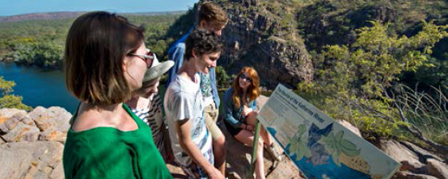

Nitmiluk Tours
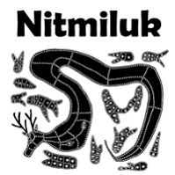
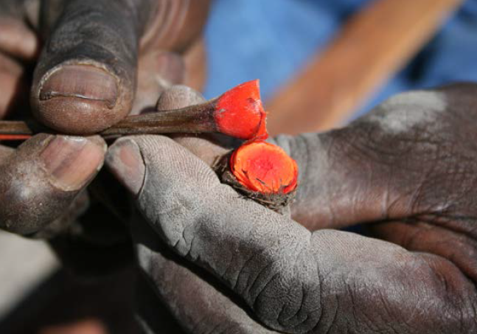
Nitmiluk Tours

Gorge Road, Nitmiluk NT
+61 (0)8 8971 1022
reservations@nitmiluktours.com.au
nitmiluktours.com.au
Nitmiluk Tours and the Jawoyn people invite your students to experience a remarkable and life-changing cultural immersion program, 'Footsteps of our Ancestors', which will inspire personal insights, ask students to question what it is to be an Indigenous Australian and expose them to the world's oldest living culture.
The focus of the program is on Indigenous education for the schools participating, but also for the Indigenous youth within our community—a reciprocal learning opportunity. The Jawoyn people still place great importance on their ancient traditions and culture, and tourism has become a way for them to teach and carry on the legacy of their ancestors to the next generation.
The 'Footsteps of our Ancestors' program encompasses the lifestyle, culture and tradition of the Jawoyn people. The full-day immersive program gives students a hands-on insight into the culture and traditional ways of the Jawoyn people. They'll learn about and taste bush foods and medicines, basket weaving, didgeridoo playing and spear throwing, fire lighting and traditional painting. This is the only program of its kind that uses interactive activities to demonstrate a typical day for the traditional Jawoyn people.
Elements of the experience deliver outcomes for a wide range of subjects, including cultural studies, social justice history, geography, Australian studies, social development, ethics, society and personal development.
Nitmiluk Tours also offers accommodation facilities and multiple activities within the Katherine region. You and your students won't want to leave!

Top Didj Cultural Experience & Art Gallery
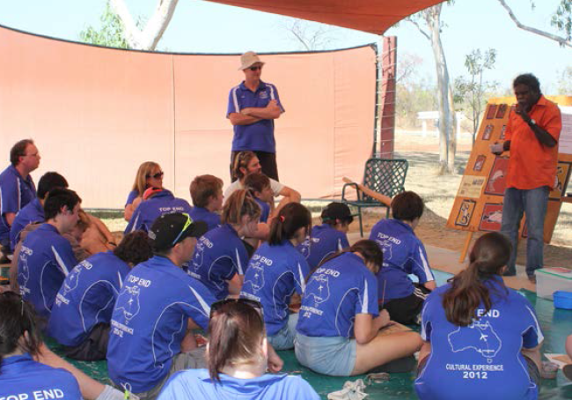
Top Didj Cultural Experience &
Art Gallery
Cnr George and Jaensch
Road, Katherine NT
61 (0)8 8971 2751
sales@topdidj.com
topdidj.com
Top Didj Cultural Experience & Art Gallery, seven kilometres from Katherine, offers your students an authentic Aboriginal cultural experience.
The art gallery displays work by artists from the regions of Warlpiri, Arnhem Land, the Kimberley and the Central Western Desert. The Cultural Experience is run by Manual Pamkal, winner of the Tourism NT Brolga Award for Outstanding Interpretive Guide in 2013. Manuel is happy to pass on his traditions from Aboriginal contemporary life after playing a traditional welcoming tune on the didgeridoo. He will teach your students the fine art of Rarrk painting and give them the chance to paint their own masterpiece using a special brush made from a reed called 'Julk'.
During this fantastic 2.5 hour interpretive experience, students will try interactive and hands-on activities such as:
- Learning about Indigenous culture and art
- Painting a piece of Indigenous artwork
- Learning fire-lighting skills
- Learning how to throw a spear using a woomera
- Hold baby wallabies
- See some of the best Aboriginal art and didgeridoos in the Northern Territory.

Katherine Outback Experience
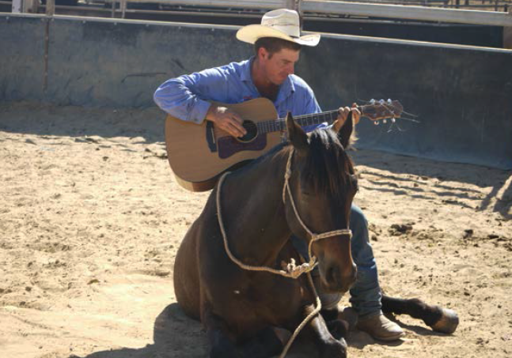
Katherine Outback Experience
Lot 2750 Collins Road, Katherine NT
+61 (0)428 264 030
tomcurtain2@gmail.com
katherineoutbackexperience.com.au
At the Katherine Outback Experience, six kilometres from Katherine, your students will enjoy an entertaining session on horse whispering, dog training, cattle mustering and country music. Tom Curtain, an award-winning country music singer, will have your students in awe of his ability to entertain as well as teach.
The program offered at Katherine Outback Experience aims to further develop students’ skills, knowledge and behaviours outside the classroom.
The program provides practical opportunities for students to investigate how they can live and work successfully in the 21st Century in a farm or rural situation. The objective is to impart knowledge and skills relating to the elements involved in working and living in this field, while contributing to areas of each student's own personal development.
The program has been designed with the following learning intentions in mind:
- Developing a strong sense of identity and wellbeing through relating with animals
- Being connected with and contributing to the students' world
- Becoming confident and involved learners
- Becoming effective communicators
Your students will love every minute of station life.

Did you know?
Katherine Gorge in Nitmiluk National Park is approximately 15 kilometres long with cliff faces up to 90 metres high in places.

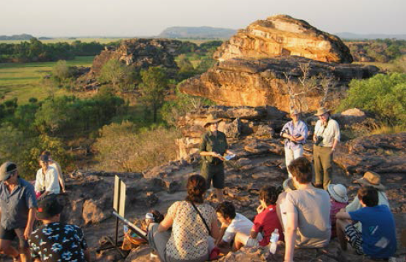
Kakadu National Park - Learning Adventures
Step back in time to an ancient classroom and learn about science and sustainability from the oldest living culture on earth.
Just a three-hour drive east of Darwin, Kakadu National Park is one of the most iconic locations in the Northern Territory. Its World Heritage assets and extensive Aboriginal history will give students an understanding of science and sustainability, Australian history and Aboriginal culture, knowledge and understanding of landforms and landscapes.
A journey to Kakadu National Park will present a range of study options such as the seasons of Kakadu, the varying habitats of this area, fire and risk management of a National Park and much more. Ranger guided activities in Kakadu National Park will interpret the park's World Heritage-listed natural and cultural values for you and your students.
Attend rock art site interpretations at Ubirr and Nourlangie, habitat and landscape walks and slideshow presentations. Visit the Warradjan Cultural Centre in Cooinda and take a walk-through the life like displays to gain an understanding of Aboriginal culture in Kakadu. Each interpretive activity showcases the ancient living culture and how it is intrinsically linked with the environment even today. Wildlife cruises are available on Yellow Water and there is a range of accommodation options. Rangers all hold current Working with Children cards.
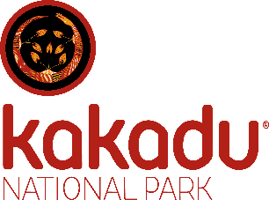
Work through our online resource to prepare your students for the excursion of a lifetime to Kakadu National Park.
For more information about Kakadu National Park contact
+61 (0)8 8938 1100, kakadunationalpark@environment.gov.au
or visit: parksaustralia.gov.au/kakadu

Kakadu Tourism
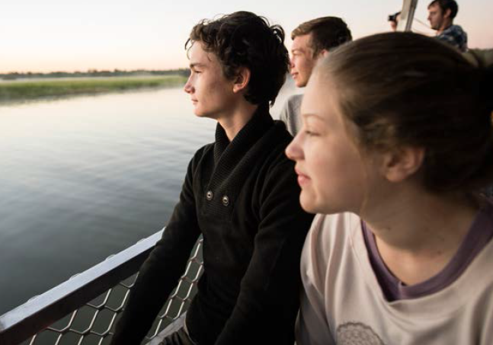

Kakadu Tourism
Cooinda, Kakadu National Park
+61 (0)8 8979 1500
reservations@yellowwater.com.au
kakadutourism.com
Kakadu Tourism is an Indigenous-owned collection of Kakadu accommodation, wetland cruises, 4WD tours and cultural experiences. We will give your students the opportunity to connect with nature in Australia's oldest classroom, and we can tailor an excursion itinerary to your curriculum needs. Nestled beside Yellow Water Billabong, Cooinda Lodge offers a variety of accommodation types, from air conditioned lodge rooms and budget dorm rooms to powered and unpowered campsites.
Yellow Water Cruises operates exclusively on Kakadu's most famous wetland, Yellow Water Billabong. Your students will learn about the birds and animals that inhabit this billabong and the importance of these waterways to the Indigenous people of Kakadu.
We can arrange excursions within Kakadu that focus on the Indigenous, European, mining and pastoral history of the region, as well as some free time for the students. The Warradjan Cultural Centre in Cooinda will give your students an insight into the culture, history and the impact of white settlement on the Bininj people (Kakadu's people) in interactive displays and exhibits.
On a learning adventure with Kakadu Tourism your students will witness one of the world's greatest nature reserves in a land that is enriched in culture and history.

Arnhem Land - Learning Adventures
Arnhem Land is an Aboriginal Reserve in the Northern Territory's north east. The major centres are Nhulunbuy (Gove) and Maningrida and Gunbalanya (Oenpelli), three small towns in an area of some 97,000 sq. kms.
Travel options range from driving in small groups in four-wheel drive vehicles, flying in charter or scheduled aircraft or a combination of all three.
Arnhem Land is known for its strong Aboriginal culture, natural landscapes and unique art style. Focus is placed on culture, and immersion programs are available through Lirrwi Tourism. These programs have been created to help develop skills for students relating to communication, intercultural understanding and ethical understanding. The unique pedagogy from the owners of the land will provide students with insight to the special connections that exist between country/place and people. First hand introduction to the Yolngu family structures and kinships will be explained for students to gain a stronger understanding of this culture.
In addition to the rich, living culture of the Yolngu people, there are examples of significant early connections with the Macassans and Malays suggesting early trade existed. Arnhem Land also has links to World War II, mining and Japanese pearling history - a great collection of study options for a variety of year levels. Wildlife, nature, culture and excitement are alive in Arnhem Land and students will remember their time here forever.
Wildlife, nature, culture and excitement are alive in Arnhem Land and students will remember their time here forever.
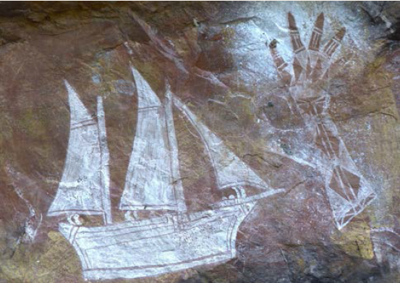

Lirrwi Tourism

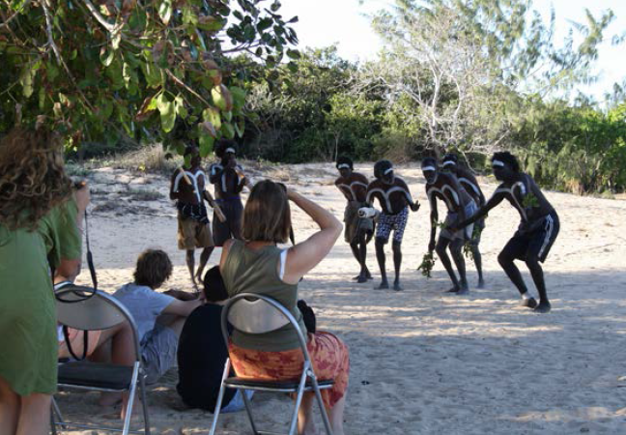
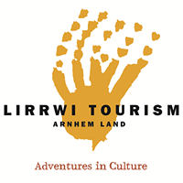
Lirrwi Tourism
84 Galpu Road, Yirrkala NT
+61 (0)8 8987 2828
info@lirrwitourism.com.au
lirrwitourism.com.au
After a visit here — where roads, cars and buildings are a rarity and bush, trees, ocean and animals are everywhere — students will return home changed people with an entirely new view on the world.
Lirrwi Tourism offers a variety of cultural experiences for all education levels, including exclusive cultural awareness camps. The camps can be tailored to curriculum requirements and include hands-on activities like spear making, pandanus basket weaving, art workshops, language workshops, bush-tucker and medicine walks and Aboriginal rangers caring for country workshops.

Darwin Region - Learning Adventures
Perched at the northern tip of Australia, with a tropical climate, small multicultural population and a unique outdoor lifestyle, Darwin is the ultimate educational excursion destination. The airport welcomes flights from most capital cities, and excursions can encompass Kakadu, Arnhem Land, Litchfield and the Katherine region by road.
Darwin has a rich and varied history around early pioneers, WWII, Asian influences and Aboriginal culture, and the city has plenty of attractions to honour it. Fascinating learning tools for all Australian students. Of particular note is Darwin's WWII history. On February 19 1942, Darwin was attacked by 242 Japanese aircraft—the first and largest single attack mounted by a foreign power on Australia. Students can investigate the impact that the bombing had on Darwin and visit attractions and memorials that tell the stories of this tragic event such as the Darwin Military Museum, Darwin Aviation Museum and the Museum and Art Gallery of the Northern Territory which also has excellent Aboriginal cultural activities, and the area's traditional owners, the Larrakia people, can provide a welcome ceremony for students.
Within the Darwin region lays some iconic places of interest, particularly for young minds. Adelaide River is an important memorial location for WWII, close to Mt Bundy, a working cattle station with accommodation where students can get involved with a variety of hands-on activities. Litchfield National park is just a 2 hour drive away and offers some fantastic flora and fauna, bushwalks, Indigenous culture and unique landscape formations.
Travelling approximately 1.5 hrs from Darwin, explore the Mary River region with a variety of educational points of interest including the Mary River Tourist Park where students can bushwalk, camp overnight and take an educational river cruise to explore the ecosystems of this area. Adventure, health and physical education are other options to discover with Basecamp Wallaroo, Adventure Bound. Spend a few days or an afternoon visiting this area. Students will develop their skill set with a variety of activities such as mountain biking, high ropes and abseiling. Participants discover different ways of communication, working together and supporting each other.
Darwin has a vast array of study options for all year levels of students covering many of the achievement standards of the Australian curriculum.
Darwin's outdoor classroom allows students to discover new life skills, encourages creativity and provides them with unique hands-on learning.
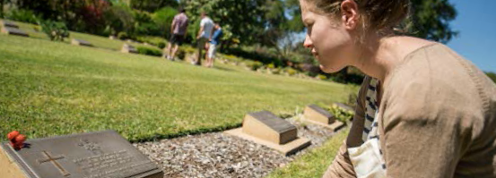

Defence of Darwin Experience (Darwin Military Museum)

Defence of Darwin Experience (Darwin Military Museum)
5434 Alec Fong Lim Drive,
East Point, Darwin NT
+61 (0)8 8981 9702
info@darwinmilitarymuseum.com.au
defenceofdarwin.nt.gov.au
The Darwin Military Museum and the Defence of Darwin Experience are located on Darwin's beautiful East Point, five minutes' drive from the city. Here students will have an immersive educational experience about the Northern Territory's WWII history and Australia's part in other military conflicts.
The museum showcases military hardware associated with men-under-arms, including WWII vehicles, uniforms, accessories and weaponry such as artillery pieces, antiaircraft guns, machine guns, mortars, rifles and many more. Students will learn about the history of Australians Under Arms from WWI to the present, including a detailed display on the Vietnam War. The Defence of Darwin Experience will give students an immersive, interactive, multimedia experience in telling the story of the first enemy attacks on Australian soil in WWII.
Students will be able to listen to the story as told by people who experienced the horrors of war and some who were present in Darwin on the 19 February 1942. Interactive displays will give students an understanding of what went on prior to and during the Darwin bombings. Students will be in awe of the real-life displays of weaponry scattered along a tropical walkway overlooking Darwin Harbour.
Please see our website with links, resources and specifically developed educational activities.

Did you know?
The bombing of Darwin in 1942 was larger than the attack on Pearl Harbour in Hawaii nearly 3 months earlier.

Sea Darwin
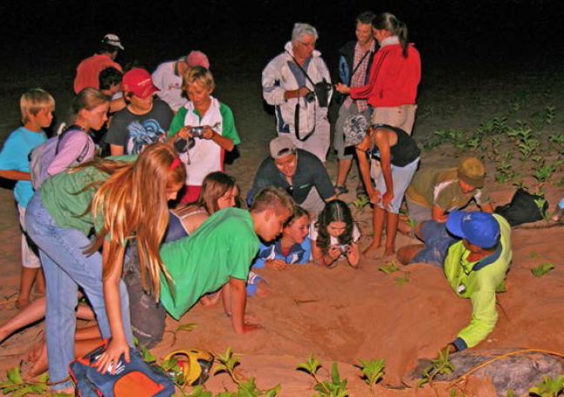
Sea Darwin
Stokes Hill Road, Darwin NT
1300 065 022
info@seadarwin.com
seadarwin.com
Experience Darwin Harbour up close in comfortable vessels with Sea Darwin. All tours are interactive and include hands-on activities as part of marine, historical or environmental interpretation.
Sea Darwin offers you and your students a variety of experiences and subject-specific cruises. Our staff have specialist skills in areas including marine science, history and Indigenous culture.
On our Turtle Encounter tour you'll visit one of Australia's most important nesting ground for flat back turtles by boat. We also offer a 'Seachange' and 'Mangroves' cruise that will allow students to identify and interpret ecosystems and the impact sea change has had on the environment.
We also offer excursions that take in significant historic sites relating to the Bombing of Darwin. This experience can incorporate a full excursion to other learning institutions such as the Darwin Military Museum and the war memorial in Adelaide River.
Our state-of-the-art marine equipment, professional guides and vessel are perfect for a class full of enquiring minds, and our tours are suited to students of all ages.

Crocodylus Park
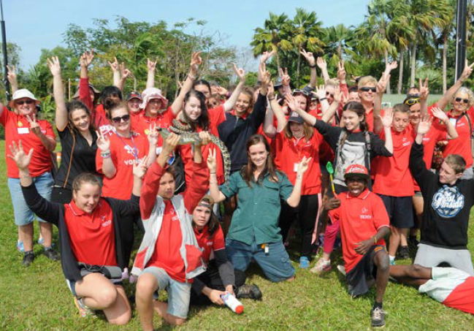
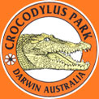
Crocodylus Park
McMillans Rd, Knuckey Lagoon NT
+61 (0)8 8922 4500
crocpark@wmi.com.au
crocodyluspark.com.au
Crocodylus Park showcases saltwater crocodiles in one of Darwin's most popular attractions, with more than 1000 animals on display — from small juveniles to massive breeding adults more than five metres long. Many crocs have been collected from the wild as dangerous animals or removed from Darwin Harbour. Also on display are American alligators, Australian freshwater crocodiles, New Guinea freshwater crocodiles and Philippine crocodiles — the world's most endangered crocodile.
Students will also get up close to our other park residents: lions, tigers, monkeys, birds, turtles, snakes, lizards and many more.
Crocodylus Park is an integral part of Wildlife Management International's research and education efforts and is one of Australia's most important public education forums on crocodiles.
Hands-on activity at Crocodylus includes handling snakes, lizards, turtles and crocs (only the little tackers of course!) Student groups can participate in crocodile feeding tours and a guided 'river' boat cruise. The river cruise occurs at Crocodylus Park on a constructed waterway featuring several Top End habitat types. This eco-cruise facilitates up close and personal viewing of a range of wildlife as well as large saltwater crocodiles.
Crocodylus Park is a committed training venue that offers work experience for school students and learning programs to help students understand these amazing animals and their environment. We offer a range of tailored school programs.

Did you know?
There are an estimated 100,000+ crocodiles in the NT. Crocodiles play an important cultural and social role for the Aboriginal people.

Territory Wildlife Park
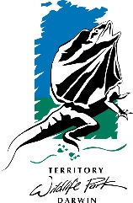
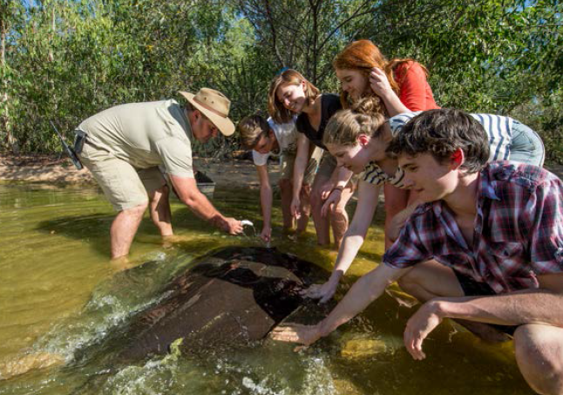
Territory
Wildlife Park
Cox Peninsula Road,
Berry Springs NT
+61 (8) 8988 7200
twp@nt.gov.au
territorywildlifepark.com.au
Located 45 minutes from Darwin, the Territory Wildlife Park is a cross between a wildlife zoo and a national park. It showcases a variety of Top End habitats—wetlands, woodlands and monsoon forest—and animal species endemic to the Top End.
School groups can use the park's facilities and take full advantage of the expertise of its guiding and zoo-keeping staff, who deliver educational programs on a variety of topics. A number of outdoor venues and exhibits can be used as living classrooms where students can immerse themselves in real habitats and interact with living creatures—an experience far more memorable and engaging than any textbook!
The park offers a range of themed student excursion packages, as well as shorter talks and encounters. One of the best experiences for students is Camp Calytrix, where they'll camp overnight at the park and take part in:
- Guided night walks, 'train' rides and animal tracking
- Early morning 'meet a keeper' presentations
- Bush tucker hunts.
A visit to the Territory Wildlife Park will provide your students with an:
- Understanding that the country around them is alive, exciting and dynamic
- Awareness of the complexity of the habitats they encounter
- Appreciation that the bush is an enjoyable place to visit and worth protecting
- Overview of the plants and animals that are native to the Northern Territory
- Opportunity to interact with keepers and guides and to learn about the science behind zoo keeping.

City of Darwin Cruises
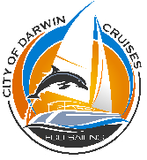
City of Darwin Cruises
Marina Blvd, Cullen Bay NT
+61 (0)428 480 090
tours@cityofdarwincruises.com.au
cityofdarwincruises.com.au
City of Darwin cruises will give your students an eco-sailing adventure around Darwin Harbour with commentary on the harbour's history and ecosystems.
Our sailing catamarans provide the best outdoor platform to enjoy and learn about this unique marine environment. The vessels are ideal for nature viewing due to their ability to sail quietly. Their wide beam allows for great stability and provides ease of movement around the vessel so everyone can view the wildlife comfortably.
Our guides are highly knowledgeable, and as the owners have science degrees and involvement with natural resource management, we can also assist with any special class requirements. We can work with educators to develop informative and enjoyable programs for all age groups. We also have educational resources available to use prior to your excursion with us to enhance the experience.
Our cruises are personal and relaxing. Students can freely chat to the skipper and crew. Our vessels are shaded with comfortable cushioned seating and a blissfully relaxing 'trampoline'.
We'll be constantly on the lookout for harbour wildlife to share with the students, like the rare snub fin dolphin, bottlenose dolphins, dugong and sea birds. Students can also join in with identifying wildlife for our harbour wildlife-recording project.
We place high importance on our environment and, in particular, the marine ecosystem, which is why we're proud to be an eco-certified ecotourism operator. You can be sure you're choosing a safe, experienced and quality operator who cares for the sustainability of the environment.
We will tailor a school excursion for you, whether it's a three-hour sunset or daytime cruise or something completely different.

Did you know?
Darwin Harbour supports a variety of ecosystems including estuarine, freshwater, tidal mud flats and mangrove systems.

Indo Pacific Marine
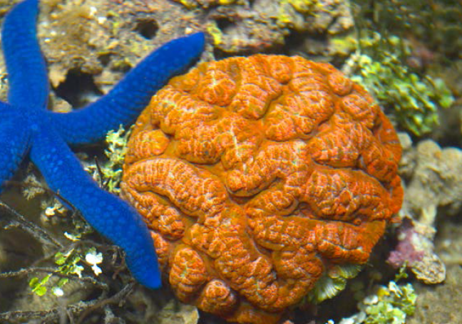
Indo Pacific Marine
29 Stokes Hill Road, Darwin NT
+61 (0)8 8981 1294
bookings@indopacificmarine.com.au
indopacificmarine.com.au
Indo Pacific Marine, at the entrance to Darwin's Stokes Hill Wharf, is a living coral reef discovery centre that features living eco systems of the fringing coral reef life of North Australia. We are members of the prestigious Marine Discovery Centre's of Australia and the NT representative of the Marine Education Society of Australasia.
We have been providing educational tours throughout our displays for more than 40 years and work with other learning institutions in Darwin. Our extensive connection with education allows us to provide an in-depth and varied learning experience. We can assist with preparation of educational resources; work with teachers to co-ordinate any lesson plans prior to your visit.
Our tours cover all levels of education, and students are able to experience a wild life environment of the NT that is normally inaccessible.

Pudakul Aboriginal Cultural Tours
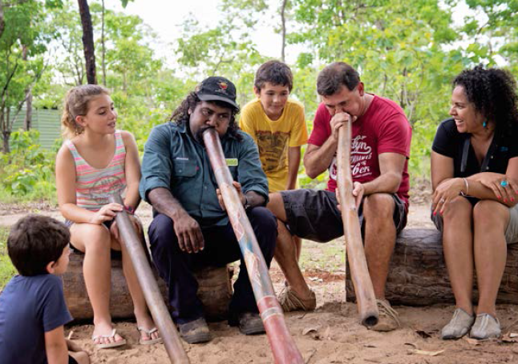
Pudakul Aboriginal Cultural Tours
Arnhem Highway, Beatrice Hill NT
+61 (0)8 8984 9282
pudakulpact@bigpond.com
pudakul.com.au
Pudakul Aboriginal Cultural Tours is a 100% Aboriginal-owned company who provide educational excursions relating to history, geography and Aboriginal culture in the Top End. Pudakul operates from the Adelaide River area on Aboriginal land near Kakadu National Park.
Learn about the history and culture of the local area on a two-hour cultural experience that delves into the rich culture and amazing landscape of this area. The interactive and hands-on experience includes a bush tucker walk and talk, didgeridoo and clap stick demonstrations and basket and dilly bag-making demonstrations.
Pudakul Aboriginal Cultural Tours operate on the Adelaide River wetlands situated only 45 minutes from Darwin. This vast area is bursting with wildlife, plants and education resources.
Other fantastic educational activities in the area include Fogg Dam, Window on the Wetlands, jumping crocodile cruises and Mary River National Park, which will only enhance the overall education experience.
We can tailor an excursion based on educational requirements.

Adventure Bound
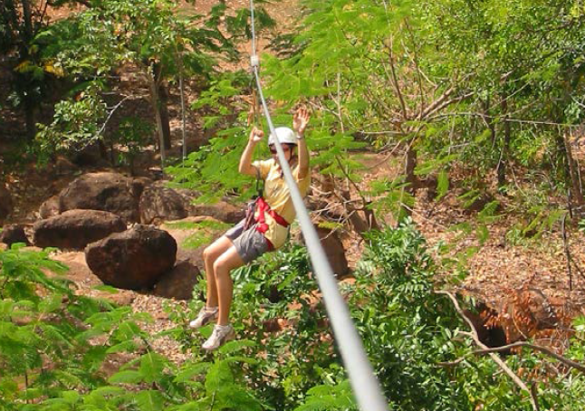
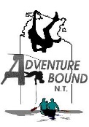
Adventure Bound
Arnhem Highway,
Mary River Region NT
+61 (0)8 8978 8884
ropeaccess@bigpond.com
basecampwallaroo.com
Make nature your classroom and adventure your tool on a school excursion to Darwin.
Adventure Bound runs an activities-based camp called 'Basecamp Wallaroo' just over an hour's drive from Darwin. The activities provide an opportunity for teachers and students to explore, learn, grow and develop strong team-building skills in an idyllic, fun and safe environment.
Adventure Bound can provide programs to help develop lifelong learning skills and capabilities, customised to meet your groups’ specific requirements. Our main focus is physical education activities suitable for senior students, like bushwalking, orienteering, abseiling and rock climbing.
Adventure Bound can also work with professional learning institutions to enhance the overall learning outcome from your Study Tour to the NT.
Your accommodation, meals, activities and guidance is all taken care of by highly trained guides, all with senior first aid certificates and Working with Children cards.

Offroad Dreaming
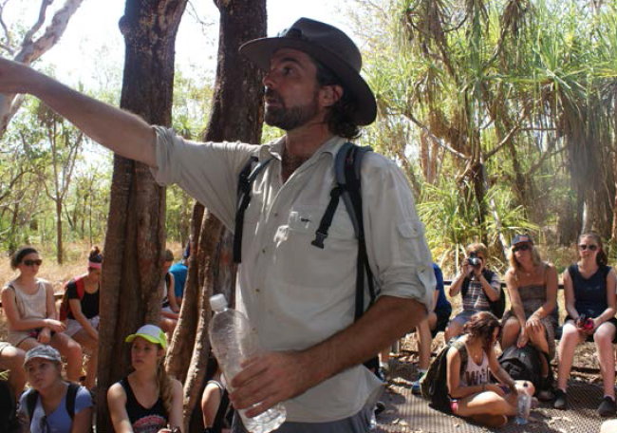
Offroad Dreaming
Darwin, NT
+61 (0)8 8931 2021
info@offroaddreaming.com.au
offroaddreaming.com.au
Join a school excursion with Offroad Dreaming and learn about flora and fauna, sustainability of the land and Indigenous culture in the Top End.
We tailor our itineraries to suit your requirements and educational needs and can arrange everything from the content of the tour, transport, accommodation and useful educational resources pre and post excursion to enhance your overall learning adventure of the NT.
Our excursions can include wetlands, crocodiles, geology, history or a collection of focus areas. Our guides' extensive knowledge allows us to take you and your students anywhere in the Northern Territory, including the Red Centre. We will provide you with the skills, knowledge and understanding of the environment, history and culture of this magnificent and unique part of Australia.
Accommodation, meals and transport facilities are chosen specifically to cater for study groups.

Did you know?
National parks and reserves make up over 45,000 square kilometres of the Northern Territory.

Darwin & Top End Learning Institutions & Accommodation

Enhance Your Top End School Education Experience
with a visit to these Learning Institutions:

Museum and Art Gallery of the Northern Territory
Conacher Street, Fannie Bay, Darwin NT
+61 (0)8 8999 8264
info@magnt.net.au
magnt.net.au
WWII Oil Storage Tunnels
Kitchener Drive, Darwin Wharf Precinct, Darwin NT
+61 (0)8 8985 6322
info@darwintours.com.au
darwintours.com.au
Parliament House
Mitchell Street, State Square, Darwin NT
+61 (0)8 8946 1414
ntparliament.edu@nt.gov.au
nt.gov.au/lant/
NT Fisheries, Darwin
+61 (0)8 8999 2144
fisheries@nt.gov.au
nt.gov.au/marine
Darwin Aviation Museum
557 Stuart Highway, Winnellie NT
+61 (0)8 8947 2145
info@darwinaviationmuseum.com.au
darwinaviationmuseum.com.au
NT Parks and Wildlife
Darwin region: +61 (0)8 89 994 555
Katherine region: +61 (0)8 89 738 888
For general NT Parks and planning information:
nt.gov.au/leisure/parks-reserves
For current NT Parks information:
facebook.com/ParksandWildlifeNT

For more information:
Tourism Top End
6 Bennett St, Darwin NT
+61 (0)8 8980 6000
info@tourismtopend.com.au
tourismtopend.com.au

Group Accommodation in the Top End

Darwin Region
Travelodge Resort Darwin
64 Cavenagh street, Darwin NT
+61 (0)8 8946 0111
darwin@travelodge.com.au
travelodge.com.au/hotel/resort-darwin
Darwin FreeSpirit Resort
901 Stuart Highway, Holtze NT
+61 (0)8 8935 0888
bookings@darwinfreespiritresort.com.au
darwinfreespiritresort.com.au
Big 4 Howard Springs Holiday Park
170 Whitewood road, Howard Springs, NT
+61 (0)8 8983 1169
reservations@big4howardsprings.com.au
big4howardsprings.com.au

Mary River Region
Mary River Wilderness Retreat
Mary River Crossing, Arnhem Highway, Annaburroo
+61 (0)8 8978 8877
info@maryriverretreat.com.au
maryriverretreat.com.au

Adelaide River
Mt Bundy Station
Haynes Road, Adelaide River NT
+61 (0)8 8976 7009
mt.bundy@bigpond.com
mtbundy.com.au

Litchfield National Park
Litchfield Tourist Park
Litchfield Park Road, Rum Jungle NT
+61 (0)8 8976 0070
relax@litchfieldtouristpark.com.au
litchfieldtouristpark.com.au

Darwin and the Top End Suggested Itineraries

Environment, Culture and Sustainability in the Top End:
8 days
Day 1
Arrive in Darwin and head to the Territory Wildlife Park with Offroad Dreaming. Explore the park for the rest of the day, before setting up camp for an overnight in the park. An exciting introduction to the flora and fauna of the Top End.
Day 2 - 4
Travel south to Katherine, where you'll stay for the next three nights camping at Nitmiluk National Park along the Katherine River. Join bush walks with a local park ranger, paddle a canoe in the Katherine River, join a gorge cruise with an Aboriginal guide and participate in cultural sessions.
Day 5
Before leaving Katherine, stop in to Top Didj for a cultural experience. Or visit a working outback station at Katherine Outback Experience.
Head into Kakadu National Park and set up camp at the Cooinda Lodge campground.
Day 6 - 7
Spend the next two days exploring breathtaking Kakadu National Park. Join bushwalks to view Aboriginal art with a park ranger who will talk about the flora and fauna of this region, culture and sustainability. Take a Yellow Water Billabong cruise and visit the Warradjan Cultural Centre. Learn about Aboriginal culture and the importance of the land, rivers and billabongs for the local Aboriginal people of this area.
Day 8
Head back to Darwin, stopping off at Window on the Wetlands for one last outlook over the Top End landscape on the way. Depart Darwin.

Darwin Experience: 6 days
Day 1
Arrive in Darwin, meet your guide and travel 20 minutes to Crocodylus Park for your first encounter with the saltwater crocodile. View these creatures up close and learn about their survival in this tropical environment.
Day 2 - 4
Today you'll experience Darwin's WWII history on an interpretive guided tour of the Darwin Military Museum. Afterwards, board a Sea Darwin cruise around Darwin Harbour for a different perspective. Continuing on with the marine theme, hang around for a night tour of Indo-Pacific Marine before enjoying dinner on Darwin's famous Stokes Hill Wharf.
Day 3 - 5
Head out of Darwin today, stopping off at Pudukul for an Aboriginal cultural experience. A little further down the road you'll come to your camp for the next three days. Camp Wallaroo is a hands-on, team building, fun learning experience for students of all ages where you'll abseil, climb, hike, bike ride and generally enjoy the outdoors.
Day 6
Depart Camp Wallaroo and head back to Darwin. Interesting attractions here are the Museum and Art Gallery of the Northern Territory, Fannie Bay Gaol and the Darwin Waterfront Precinct.

Cultural immersion tours
For an in-depth cultural immersion program where students have access to Aboriginal land, interaction with Aboriginal people and hands-on learning, we suggest the following operators:
- Lirrwi Tourism
- Pudukul Aboriginal Tours

Operators Who Can Make Arrangements for Your
NT Study Tour:
AAT Kings
Ph: +61 (0)2 9028 5053
charters@aatkings.com.au
aatkings.com
Away We Go Tours
Ph: +61 (0)2 6456 4033
admin@awaywegotours.com.au
awaywegotours.com.au
GET Education Tours
Ph: +61 (0)3 8842 1100
contact@getours.com.au
getours.com.au
Territory Discoveries
Ph: +61 (0)8 8968 3200
groups@territorydiscoveries.com
territorydiscoveries.com
WorldStrides
Ph: +61 (0)3 8325 0000
info@worldstrides.com.au
worldstrides.com.au
Across Australia Travel
Ph: +61 (0)3 9370 1499
wtstours@bigpond.com
acrossaustraliatravel.com.au

Photography provided by Tourism NT and Peter Eve.
DISCLAIMER
Tourism NT provides this information to promote tourism in the Northern Territory as a service to the community. Tourism NT does not warrant, and makes no representation, as to the accuracy of any information or its suitability for you. You must make your own enquiries to satisfy yourself that the information is accurate. You should not rely on this information to make decisions. Tourism NT disclaims any and all liability arising from your use of, or reliance on, this information. You indemnify, and keep Tourism NT indemnified, against all claims, and all costs arising from claims, brought by you or by any third parties arising from your use of, or reliance on, this information.

