Savannah Way
Pack up the four-wheel drive with camping and fishing gear, and hit the Savannah Way. This journey of a lifetime will take you from Cairns in Queensland through the savannah landscapes of the Northern Territory and on to Broome in the West. The route follows a mostly sealed highway although there are some long stretches of gravel road and four-wheel drive trails to take.

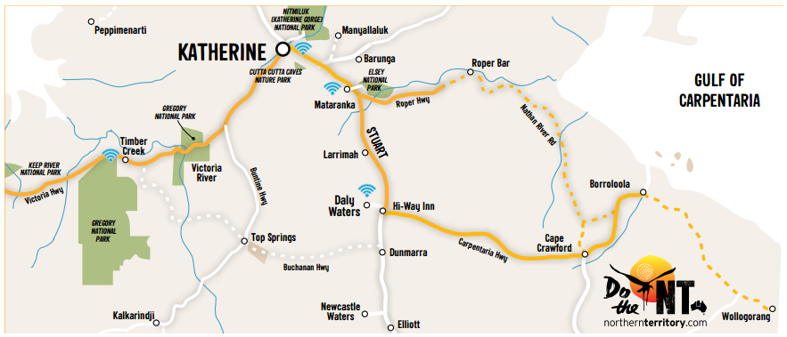

DO BORROLOOLA
Next to the MacArthur River, Borroloola is a must-do along Savannah Way. This fishing enthusiast’s paradise has excellent estuary and open water fishing. Take a few days to land an iconic barramundi, or explore the Sir Edwards Pellew Group of Islands in the Gulf of Carpentaria.
DO CAPE CRAWFORD
Do a chopper flight over the iconic Lost City or take a walk amongst the giant sandstone pillars. Paddle to the end of a beautiful gorge to relax in Poppy’s Pool which stays at a constant pleasant 27 degrees.
DO ROPER BAR
For spectacular fishing action, head to the tidal pandanus-fringed Roper River and stay the night at the Munbililla camp ground. An exciting four-wheel drive adventure, Roper Bar is a fantastic getaway from the buzzing city-life.
DO DALY WATERS
Between Katherine and Tennant Creek is a unique pub that could only belong in the NT. Daly Waters Pub attracts visitors from all over Australia and beyond, wanting to relax after a long drive and enjoy Daly’s famous outback tucker, cold beer and live music.
DO KATHERINE
Where the outback meets the tropics - discover a region full of gorges and waterfalls, thermal springs and rich indigenous culture. There’s dozens of ways to explore Katherine Gorge and Nitmiluk National Park including by canoe, dinner or cultural cruises and walking trails.
DO VICTORIA RIVER
Just a short walk from the camping area lies great fishing and bird-watching spots. Feeling more adventurous? Take a 90 minute meander up the soaring rocky escarpments on the Escarpment Lookout Walk and you’ll be rewarded with amazing panoramic views of the valley below.
DO JUDBARRA/GREGORY
Victoria River Roadhouse is the gateway to sensational fishing and four-wheel drive adventures of Judbarra / Gregory National Park. Discover historic and Aboriginal sacred sites, the magnificent boab tree or even try out bush camping immersed in a fantastic natural backdrop.
TOP 10 MUST-DO’S FOR SAVANNAH WAY
- Explore the iconic Great Barrier Reef at Cairns
- Visit outback cattle station Seven Emu Station and its Australian Wildlife Conservancy
- Hook a barramundi at Borroloola
- Fly over Cape Crawford for breathtaking views of the Lost City
- Do Limmen National Park with its many rivers and remote camping grounds
- Discover quirky outback pubs and enjoy their authentic hospitality
- Plunge into crystal clear waterholes and rejuvenating thermal Poppy’s Pools
- Canoe through the gorges at Nitmiluk National Park
- Take a four-wheel drive adventure in Judbarra / Gregory and Keep River National Parks
- Watch the sunset over pristine beaches in Broome
DAY 1-6 - 1131km
CAIRNS TO NT BORDER
Escape the coast and explore the gulf country with cattle stations, camping grounds and outback characters waiting to meet you.
DAY 7-8 - 262km
NT BORDER TO BORROLOOLA
Head through to the Gulf of Carpentaria for great fishing and nature watching. Make a stop at Seven Emu Station a genuine Australian outback cattle station, and enjoy camping, fishing, birdwatching and Aboriginal culture on this genuine outback cattle station.
DAY 9
BORROLOOLA
Borroloola is a must-do for fishing enthusiasts. Land an iconic Barramundi or explore the Sir Edward Pellew Group of Islands. Explore Caranbirini Conservation Reserve just 46km south of Borroloola for stunning views and excellent bird watching.
DAY 10 - 100km
BORROLOOLA TO CAPE CRAWFORD
Explore the iconic Lost City by a chopper flight. The fly-in tours also offer on the ground access to walk among the giant sandstone pillars. Smaller sections of the Lost City can be accessed by vehicle in Caranbirini and Limmen National Parks.
Just 70km away at Bauhinia Downs Station, you can paddle Poppy’s Pool to relax in the 27 degree water wonderland.
DAY 11 - 374 / 387km
CAPE CRAWFORD TO ROPER BAR / DALY WATERS
For four-wheel drive route, travel north to Roper Bar, on the tidal pandanus-fringed Roper River for more spectacular fishing action and stay the night at the Munbililla (Tomato Island) camp ground.
For alternative sealed route, head to Daly Waters and check out Australia’s war and exploration history. Call in for a cool drink and outback meal at the always entertaining Daly Waters Historical Pub.
DAY 12 – 183 / 168km
ROPER BAR / DALY WATERS TO MATARANKA
For sealed and unsealed routes, head to Mataranka, just 400km from Darwin and plunge into the thermal pools and crystal clear streams including Mataranka Thermal Pools and the lesser known Bitter Springs that sit among the massive palm trees. Or take an easy stroll through Elsey National Park.
DAY 13 - 106km
MATARANKA TO KATHERINE
Head north to explore Nitmiluk National Park near Katherine and choose your level of adventure - from swimming spots, canoeing, scenic helicopter flights or take a guided boat cruise through Katherine Gorge.
DAY 14 - 286km
KATHERINE TO JUDBARRA / GREGORY NATIONAL PARK
Victoria River Roadhouse is your gateway to scenic adventures with great fishing and walking trails through stunning escarpment scenery. Meander up the rocky Escarpment Lookout Walk and be rewarded with panoramic views of the river and valley below.
DAY 15 - 228km
TIMBER CREEK TO KUNUNURRA
Explore the park’s four-wheel drive network to discover the history of Bullita Homestead, fascinating walks, cattle station history. Stay the night in the campground, or call ahead and visit Bullo River Station for a real taste of Australian outback station life. Accommodation is also available at Timber Creek, Top Springs and Victoria River.
DAY 16-20 - 1043km
KUNUNURRA TO BROOME
Explore the bushwalking tracks of Keep National Park, just 3km before the WA border, to discover similar sandstone landforms to the Bungle Bungles.
The Jinumum and Lang-Gerrbi walks are a good chance to view Aboriginal rock art up close before you continue your Savannah Way adventure into WA.

