Red Centre Way

Travel through red desert sands, lush valleys, towering gorges and a number of waterholes, on this iconic journey. The 1135km Red Centre Way loop from Alice Springs makes its way to the Tjoritja / West MacDonnell Ranges, Watarrka/Kings Canyon, and Uluru-Kata Tjuta National Park.
The Red Centre Way journey is recommended to be done over a minimum 6 days via four-wheel drive, or spare some extra time to complete the completely sealed 1750km loop if travelling by two-wheel drive.
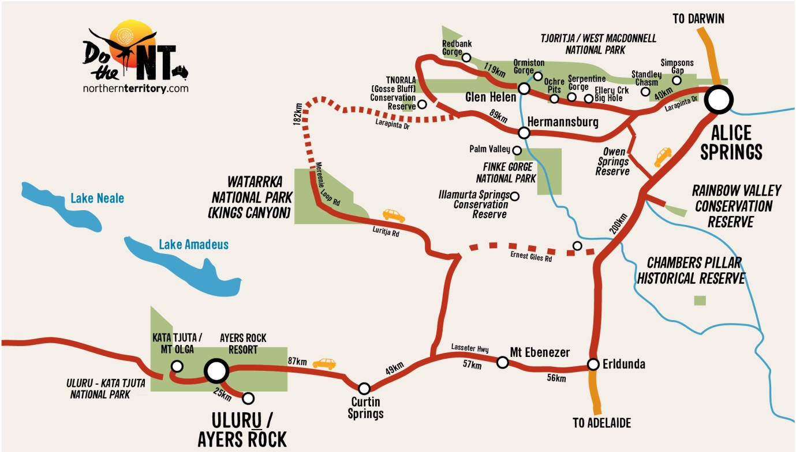

DO THE GHAN
Experience one of the world’s great train journeys. With scheduled services running both directions between Adelaide-Alice Springs, Adelaide-Darwin and Alice Springs-Darwin, it is by far the most romantic way to travel to the Northern Territory.
DO RAINBOW VALLEY
Located just 97 kms south of Alice, explore the wonders of this ancient landscape by relaxing in a guided tour, or create your own four-wheel drive adventure. Be sure to check out the sandstone bluffs and cliffs at dawn or dusk when the rainbow-like rock bands are at their finest!
DO ALICE
Discover the spiritual heart of Australia, with rivers and stunning ranges millions of years old and an ancient Aboriginal culture rich in art and stories. Alice Springs is your base for adventure and easier to get here than you think!
DO THE CANYON
The majestic Kings Canyon features 100m high sandstone walls, palm-filled crevices and amazing views that stretch across the landscape. Why not stay longer and explore the walking trails, quad bike tours, cultural experiences and relax overnight in comfortable accommodation or camp under the stars.
DO WEST MACS
Explore Tjoritja / West MacDonnell National Park, an adventure playground with waterholes, hiking trails and camping spots, stretching 161km west of Alice. Home to iconic spots such as Ormiston Gorge, Ellery Creek, the Ochre Pits, Hermannsburg, and Standley Chasm – the West Macs are a must-do on your Alice itinerary.
DO ULURU
Discover the spiritual heart of the Aussie Outback. Blessed with natural beauty, this desert region is home to the famous Uluru-Kata Tjuta and Watarrka National Parks. Enhance your iconic landscape experience with world-class dining packages such as Sounds of Silence and Tali Wiru.

TOP 5 MUST DOs
- Get the adrenalin pumping in Alice Springs with a mountain bike riding tour
- Make your own paper from native grasses at Curtin Springs Station
- Take the Rim Walk at Kings Canyon for unforgettable sights of this ancient beauty
- Trek the red sands on a camel safari as the desert comes to life at sunrise on Uluru
- Soak up the views of the sandstone bluffs and cliffs at Rainbow Valley
DAY 1 - 132km
ALICE SPRINGS TO GLEN HELEN
Start the Red Centre Way by driving west through the West MacDonnell National Park, a spectacular stretch of natural formations including chasms, gorges and waterholes. Explore Simpsons Gap, Standley Chasm, Ellery Creek, Ormiston Gorge and Glen Helen just to name a few. Splash, hike or just be in awe – it’s truly spectacular!
DAY 2 - 234km
GLEN HELEN TO KINGS CANYON
From Glen Helen head 20km west to start the day with a swim at Redbank Gorge pools. You can grab a tyre tube from Glen Helen Resort and splash your way through the gorge. If travelling by 4WD you can continue along the way to come across the ancient impact crater called Gosse Bluff. Hike to the top where you can get spectacular views of the rides made from the meteorite.
DAY 3
EXPLORE KINGS CANYON
Kings Canyon is only minutes from the resort and offers hiking suitable for all levels. The Rim Walk is a 3 hour adventure across 100m-high sandstone walls and ancient palm-filled crevices with stunning views of the arid surrounds. For those looking for a more relaxed option, the Kings Creek walk provides equally breathtaking views from the canyon floor.
DAY 4- 300km
KINGS CANYON TO ULURU
Leave the canyon and follow Luritja Road and Lasseter Highway to Uluru-Kata Tjuta National Park. Along the way you will pass Mt Conner, commonly known as ‘Fooluru’, as it’s often mistaken for Uluru. Do the unexpected and view the Lake Amadeus salt plains near the Mt Conner look out.
Once you arrive at Uluru, settle in at Ayers Rock Resort, where there are accommodation and dining options available to suit all budgets and tastes.
DAY 5
ULURU & KATA TJUTA
Do Uluru and Kata Tjuta in a day or in many. See the icons at sunrise, sunset, on a camel or by bicycle. Listen to the local Anangu people as they tell their stories of the Dreamtime. Explore Kata Tjuta on the Valley of the Winds walk and take in Uluru up close on the Base Walk. You can touch, smell and explore these icons of Australia’s Outback.
DAY 6 - 445km
ULURU TO ALICE
Start your return trip to Alice Springs – head back along the Lasseter Highway, to Curtin Springs Station – a working cattle station and roadhouse. Join a guided walk on the nearby salt lakes and take in the view of Mt Conner or try your hand at a papermaking tour using native ingredients.
Turn north onto the Stuart Highway towards Alice. If four-wheel driving, leave time to explore the sandstone bluffs and cliffs of Rainbow Valley, which are particularly stunning in the early morning and late afternoon light when the rainbow-like rock bands are highlighted. From here Alice is only 100km away.

