Overlander’s Way
The Overlander’s Way is an experience you will never forget. This self-drive track served as an important line during World War II and stretches across 1550 kilometres taking you from the ocean to the outback. You can travel from the Great Barrier Reef to Australia’s outback in a matter of days, so make sure you pack your flippers and hiking boots.
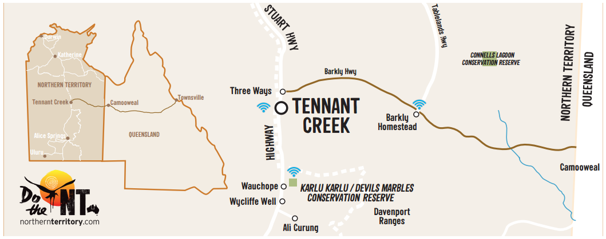
DO CAMOOWEAL
The Gateway to the NT celebrates the outback with its Drovers Reunion and Festival with plenty of boots, dust and fine yarns. Be sure to visit the caves before crossing the border and starting your NT adventure.
DO CONNELLS LAGOON
Situated in the heart of the Barkly Tableland, the Connells Lagoon Conservation Reserve is home to an abundance of native flora and fauna. Have a go at spotting these, especially the protected endangered native wildlife.
DO RODEO
Join the hundreds of locals that flock to Brunette Downs Station for a rodeo event not to be missed. The Brunette Downs races is held over a weekend around June each year, and sees everything from horse racing, rodeos, camp drafting to bush poetry competitions.
DO HOMESTEAD / THREE WAYS
Need a pit stop? Barkly Homestead and Threeways Roadhouse offer relief for weary travellers with cold drinks, accommodation for travellers, great meals, and big skies full of a million stars.
DO CULTURE
Discover the Indigenous culture of Tennant Creek and surrounds. Make a stopover at Nyinkka Nyunyu to meet the locals and see real Aboriginal art for yourself.
DO TENNANT CREEK
Experience the 1930’s gold rush times at Battery Hill Mining Centre. Pan for your own gold and tour the underground mine to see the machinery in action. Stop in at Kelly’s Ranch and saddle up for the ultimate outback experience with a basic horse riding lesson or trail ride with traditional Aboriginal man and experienced horseman, Jerry Kelly.
DO DEVILS MARBLES
Make sure you visit Karlu Karlu, also known as the Devils Marbles and walk amongst these ancient boulders, some of which stand over 6m high. Pull out a blanket and picnic, and watch the domes change colour at sunrise or sunset.
DO DAVENPORT RANGES
Why not extend your journey and visit Iytwelepenty / Davenport Ranges for a great place to relax after a long drive. With fantastic scenery and walking trails, this lesser known national park has plenty to see.
TOP 5 MUST-DO’S FOR OVERLANDER’S WAY
- Visit Karlu Karlu (Devils Marbles) to see the gigantic granite boulders glowing in the late afternoon or at sunrise.
- Share tales of the stockman’s life as you look for bush tucker on a horse trail with a traditional local man from the region.
- Take a four-wheel drive side-trip to explore the Davenport Ranges and enjoy a night camping under a million star sky.
- Learn about the Warumungu people at the multi-award winning Nyinkka Nyunyu Art & Culture Centre.
- Experience an outback gold rush, and search for your own gold at Battery Hill Mining Centre.
DAY 1 - 138km
TOWNSVILLE TO CHARTER TOWERS
Beginning at the tropical city of Townsville in Queensland, be sure to take in the magnificent Great Barrier Reef. Kick off your drive to Charter Towers and explore the history-filled small town. Discover the World War II bunkers, visit Pioneers Cemetery and if you’re feeling brave join the ghosts of gold heritage trail. Wind down and enjoy the best steak in town at the Cattleman’s Steakhouse Restaurant.
DAY 2 - 252km
CHARTER TOWERS TO HUGHENDEN
Continue down the track and stop in Hughenden, a peaceful town situated on the banks of the Flinders River known for all things ‘dinosaur’. Visit ‘Hughie’, the famous full-size dinosaur skeleton discovered in 1963, or if you’re in town at the time, be sure to check out the Hughenden Dinosaur Festival.
DAY 3 - 115km
HUGHENDEN TO RICHMOND
Continue your dinosaur adventure at Richmond. Take the kids on the Australian Dinosaur Trail for plenty of hands-on fossil fun.
DAY 4 - 149km
RICHMOND TO JULIA CREEK
Julia Creek was used as a major transport hub for freight and passengers before the expansion of the railway. Set up camp along the water’s edge, and relax with some wine and cheese at sunset. See if you can spot the endangered but feisty marsupial, the Julia Creek Dunnart.
DAY 5 - 257km
JULIA CREEK TO MOUNT ISA
Another 137km down the track you’ll find the cattle-grazing town of Cloncurry, adjacent to Cloncurry River. Here you’ll discover the history of the first Royal Flying Doctor Service, established in 1928, at the John Flynn Place Museum and Art Gallery. Mount Isa offers underground mine tours, or try your luck digging for fossils at the Fossil Centre.
DAY 6 - 190km
MOUNT ISA TO CAMOOWEAL
Find your way to Camooweal, the ‘Gateway to the Northern Territory’.
Make sure you stop in at the caves on the edge of the Barkly Tablelands at the Camooweal Caves National Park. Get back to nature and set up camp in one of the campgrounds just outside of the park where you can enjoy birdlife and amazing sunsets.
DAY 7 - 260km
CAMOOWEAL TO BARKLY HOMESTEAD
Now it’s just a short drive to the NT border. Once you’ve passed the border there’s plenty to do before you hit Tennant Creek.
Detour to Connell’s Lagoon to see some of Australia’s endangered wildlife. If you’re here in June, visit he famous Brunette Downs Station Rodeo, where hundreds of locals flock to town and dress up for the event.
DAY 8 - 212km
BARKLY HOMESTEAD TO TENNANT CREEK
Onwards to Tennant Creek, there’s plenty of history to discover. Check out the Aboriginal history Nyinkka Nyunyu, then go to the Battery Hill Mining Centre and experience the underground mines for yourself.
Just south of Tennant Creek lies Karlu Karlu / The Devil’s Marbles. These large domed rock formations are a great place to walk around, and the perfect spot to set up a picnic.
Finish off the trip at the beautiful Iytwelepenty / Davenport Ranges. This 1120 square kilometre national park has many walking tracks, glorious natural waterholes and camping spots.

