Nature’s Way
For a drive that highlights the best of the Top End, look no further than Nature’s Way. In five to ten days you can have an amazing adventure that links Darwin, Australia’s vibrant tropical capital city with the ancient cultural and natural wonders of Kakadu, Nitmiluk and Litchfield National Parks.
This easy drive is completely on sealed roads with some great four-wheel drive side-trips to take you to special spots in the lush northern tropics.

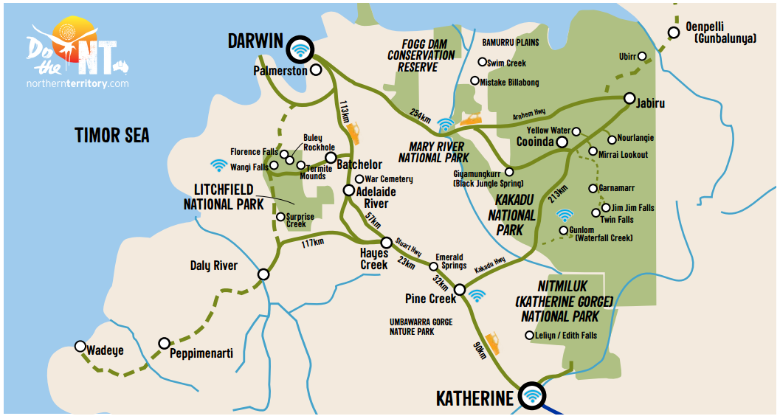

DO DARWIN
Try something adventurous in Australia’s tropical capital city - ride the swell at the Wave Pool, eyeball a croc in the Cage of Death, or do as the locals do and enjoy one of Darwin’s famous Asian inspired markets.
DO LITCHFIELD
Only an hour from Darwin, the Top End’s beloved Litchfield National Park has something for everyone. Enjoy a dip in one of its many swimming spots, take a short or overnight hike, or discover the hundreds of species of fauna and flora that thrive in the area.
DO KAKADU
Less than three hours from Darwin, Kakadu is Australia’s largest National Park with Aboriginal rock art sites and stunning landscapes teeming with wildlife. Explore on foot, join a cruise or guided tour, spot crocs and birdlife, or make a splash in the waterfalls.
DO NITMILUK
Take a drive just outside of Katherine to the vast Nitmiluk National Park (Katherine Gorge) and explore its staggering network of gorges, carved through ancient sandstone by the Katherine River. Enjoy the magnificent views from above, via helicopter, from the water or on foot.
DO KATHERINE
Where the outback meets the tropics - discover a region full of thermal springs, pioneer history and ancient culture. Create your own Indigenous artwork at an Aboriginal Cultural Experience or get a unique view of the outback at a horse-breaking and working dog demonstration.
TOP 5 MUST-DO’S
- Mindil Beach Markets where you can choose from over 1200 exotic dishes and watch the famous Top End sunset
- Hike up to nature’s infinity pool at Gunlom Falls and swim with magnificent views over Kakadu
- Tour to the Aboriginal art centres of Tiwi Islands, and see why their traditional artworks are world-famous
- Take a helicopter tour over Katherine Gorge for spectacular views of Nitmiluk National Park
- Be amazed by the stories of the world’s oldest living culture in the rock art at Nourlangie and Ubirr in Kakadu

Do Nature’s Way – 7 day suggested itinerary
Take the scenic route – drive from Darwin to Katherine via Kakadu National Park along Nature’s Way. The 550km drive can be done as a one-way trip or a longer 945km loop back to the capital. Nature’s Way journey is recommended to be done over a minimum seven days, here is a suggested way you could enjoy the journey.
DAY 1 - 250km
DARWIN TO KAKADU
The rare and unspoiled beauty of Kakadu National Park is only a three-hour drive from Darwin. On your way to the park, along the Arnhem Highway, there are several opportunities to see wildlife in its natural environment. Stop at the Adelaide River and board a cruise to see huge saltwater crocs jump for food from the safety of the riverboat.
DAY 2 & 3
KAKADU NATIONAL PARK
Kakadu is a World Heritage-listed site and Australia’s largest national park. Explore and cruise its waterways to see crocs and birdlife, walk through ancient Aboriginal rock art galleries, or join a guided tour. Take in the stunning view of the wetlands from above at the Ubirr lookout at sunset.
DAY 4 - 300km
KAKADU TO KATHERINE via Pine Creek
Head south along Kakadu Highway to Pine Creek, a small town that experienced a rush for gold in 1871. A further 90km down the road is Katherine, a great place to base yourself and explore the region. It is the gateway to at least sixteen national parks, nature parks, reserves and conservation areas, including Katherine Gorge (Nitmiluk National Park). Take a refreshing dip in the Katherine Hot Springs – a series of clear pools fed by a natural thermal spring located on the banks of the Katherine River.
DAY 5
NITMILUK NATIONAL PARK
Nitmiluk National Park is only a short 30km drive from Katherine. There are many options to explore the park – via air on a helicopter flight, from the water on a guided cruise or by canoe, or on foot with well-marked paths.
DAY 6 - 265km
KATHERINE TO LITCHFIELD
Why not make stop in at Edith Falls on your journey north and enjoy a swim in the pandanus-fringed plunge pool. Just 2½ hours drive away, Litchfield National Park is renowned for its accessible, unspoiled wilderness of monsoon rainforests and waterfalls that flow year-round. Cool off with a swim in the plunge pool below the permanent spring-fed Florence Falls or wade through the rock pools at Buley Rockhole.
DAY 7 - 130km
LITCHFIELD TO DARWIN
Head back to Darwin via the Territory Wildlife Park. Wander through treetop aviaries, around a natural lagoon and walk through the aquarium to see animals, including the saltwater crocodile, in their natural habitats. Before you enter Darwin, stop at Berry Springs Nature Park. A recreation camp for armed forces personnel during the war; today it is a popular spot for a picnic and a dip in freshwater pools.

