Binns Track
The Binns Track is an epic four-wheel drive adventure that takes you through spectacular scenery allowing you to explore some of the lesser-known sights of Central Australia and the grandeur of big rivers in northern NT.
Starting from the SA/NT border up to Timber Creek, this track is 2,230km in distance and was named after Bill Binns, a Ranger with NT Parks and Wildlife for 32 years. Bill’s dream was to create a track that allowed tourists to explore regions bursting with colours, native wildlife and mighty rock formations.
DO ALICE SPRINGS
Get up close with the native flora and fauna at Alice Springs Desert Park and the Reptile Centre. Join a mountain biking tour and ride along a number of dirt tracks suitable for any fitness level. Or if you have a spare few days, why not explore the beautiful rocky gorges along the West MacDonnell Ranges.
DO GEMTREE
Gem Tree is a great place to camp. Why not try your luck fossicking for semi-precious gem stones. As the name suggests, you might find Zircons or rich red garnets here.
DO DAVENPORT
Take in the serenity or jump in and cool down in the water at Iytwelepenty/ Davenport Ranges National Park. The camping area at Old Police Station Waterhole is a beautiful spot to pitch your tent, especially when the creek is full of water.
DO TENNANT CREEK
Take a break at Karlu Karlu / Devils Marbles. Wander through the maze of ancient boulders that reach up to 6m in height. Pull out a rug, and enjoy the sunset with some wine and cheese.
DO DUNMARRA
Check out the heritage-listed attraction, the Frew Pond Overland Telegraph Line Memorial Reserve where the two ends of the line first joined in 1872. Stretch your legs by taking a hike along the easy 1.5km track which includes 52 of the original Oppenhiemer poles.
DO TIMBER CREEK
Catch a rare glimpse of early life in the NT at the Timber Creek Police Station Precinct. Be sure to join in the Timber Creek Festival, which showcases local indigenous talent and traditional dance. Join in the festivities and try your luck at whip cracking or spear throwing.
TOP 5 MUST-DO’S
FOR BINNS TRACK
- Visit the Alice Springs Desert Park for your chance to get up close with Central Australia’s flora and fauna
- Join a mountain biking tour around the old Telegraph Station of Alice Springs
- Explore abandoned gold mines at Arltunga and pan for your own gold
- Discover the Davenport Range and enjoy a night camping under sky filled with a million stars
- Take a scenic chopper flight over Judbarra / Gregory National Park from Victoria River Downs, once the world’s largest pastoral station
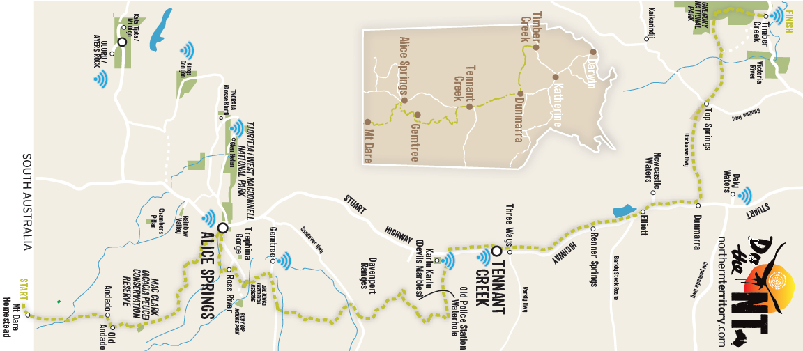
DAYS 1 & 2 - 421km
MT DARE TO ALICE SPRINGS
Starting at the SA/NT border, the track begins at Mt Dare. Watch the sunrise here before setting off on the 421km journey along Old Andado Track to Alice Springs. Flanking the western fringe of the Simpson Desert, the track passes sand ridges 5-8m high and meanders through the Finke River flood-out. Enjoy a picnic lunch at Molly Clark’s Old Andado Homestead and unwind in its old-world charm.
Take a night or two to enjoy Alice Springs. This small town has unexpected experiences and all levels of accommodation from camping sites to 4-star hotels. Rise early and watch the sun rise from a hot air balloon or take in sunset from the back of a camel. Visit Alice Springs Desert Park and get up close to the native flora and fauna, including the Wedge Tailed Eagle or the endangered bilby.
Spend a few extra days and check out the gorges, waterholes and world-class hiking trails in the West MacDonnell Ranges just next to Alice Springs.
DAYS 3 & 4 - 287km
ALICE SPRINGS TO GEM TREE
Continue on to Ruby Gap Nature Park (4WD access only) and take in the sights including native birds and wildlife along the river bed. If you wish to stay the night, set up your campsite along the river bed.
Follow the Pinnacles Track to Gemtree on the Plenty Highway, through the breathtaking scenery of the rugged Harts Ranges. Camp overnight at a powered or unpowered caravan and camping site, or in a cabin. Try your luck fossicking for semi-precious stones such as Zircons and red garnets.
DAYS 5 & 6 - 692km
GEM TREE TO TENNANT CREEK
Continue on 422km to Iytwelepenty / Davenport Ranges National Park. Take in the serenity or jump in and cool down in the water.
Travelling from the Ranges to Tennant Creek, take a short detour to Karlu Karlu / Devil’s Marbles which is home to the massive granite boulders and a must do on your Binns Track itinerary. Walk amongst these ancient boulders that stand up to 6m high. Best to visit at sunrise or sunset when they glow red and change colour. Be sure to bring your camera for this truly beautiful sight.
DAYS 7 & 8 - 358km
TENNANT CREEK TO DUNMARRA
Stopover in Tennant Creek to explore its many fascinating historical attractions. Continue north driving past expansive cattle stations and limestone landscapes. Soak up the history of the Frews Pond Overland Telegraph Line Memorial Reserve. Created as a tribute to Sir Charles Todd, this heritage attraction pays homage to the building of the Overland Telegraph Station.
Stretch your legs by taking an easy walk along the 1.5km track which includes 52 of the original Oppenhiemer poles allowing you to witness some of NT’s earliest history.
DAYS 9 & 10 - 471km
DUNMARRA TO TIMBER CREEK
You’ll drive along an unsealed road passing through Bullita Homestead (also a great place to set up camp). Explore the houses and original timber stockyards of the regions pioneers.
Continuing along the track, you’ll pass by interesting rock formations along Limestone Creek and then arrive at your final destination, Timber Creek. Here you can catch a glimpse of the early life in the NT at the Police Station Precinct. Or join in the festivities of the Timber Creek Festival and try your luck at whip cracking or spear throwing.

