Arnhem Way

Considered one of Australia’s last unspoilt areas, Arnhem Land is just waiting to be discovered. The Central Arnhem Road starts 50km south of Katherine and finishes in Nhulunbuy on the Gove Peninsula.
This route will take you on an adventure through open savannah woodlands as you cross creeks and spot a variety of wildlife. Please note that when travelling to Arnhem Land you will require a permit from the Northern Land Council. These permits are necessary to preserve the beauty of Arnhem Land.
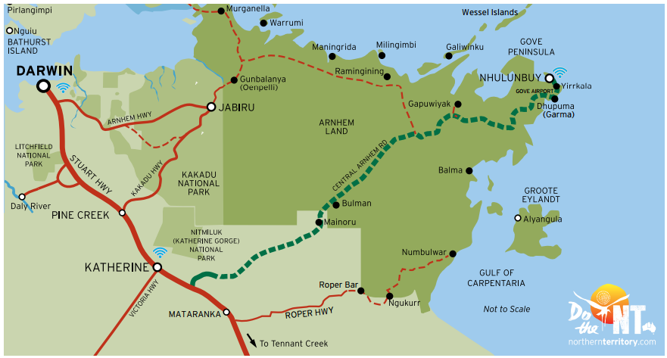
DO CULTURE
Arnhem Land has a unique Indigenous culture that is perfectly interwoven into the experiences available. The small population is mainly Aboriginal people who live a traditional life. Take a cultural tour or visit the local art and craft galleries to experience authentic Aboriginal culture. This is the land where the didgeridoo originated, so make sure you visit the local art and craft galleries to secure your authentic souvenir.
DO ADVENTURE
This coastline is home to some of Australia’s most beautiful pristine beaches just waiting to be explored. Join a fishing charter and spend the day out on the water or explore various bushwalking and hiking trails through unique wetland settings where you can spot native wildlife and rare birds. Pitch a tent and camp the night and finish the day with a sunset you will never forget.
DO FISHING
You’ll find some of the best sports fishing in the world in Arnhem Land. Here you can catch Red Emperor, Spanish Mackerel and Coral Trout. Make sure you jump on a blue water fishing experience with one of the charter tours available based in Nhulunbuy (Gove). For the more adventurous why not try and catch your lunch by spearfishing in the shallow waters.

TOP 10 MUST DO’S
- Bush camp at pristine beaches along the East Arnhem Land coast
- Explore the beaches and fresh water holes of the Dhimurru recreational areas on a four-wheel drive camping adventure
- Jump on a charter flight and see the fantastic coastline and wildlife from above
- Visit Buku Larrnggay Mulka Art Centre at Yirrkala for local Indigenous arts and crafts
- Visit the many local beaches for stunning coastal views
- Try your luck on a full day blue water fishing charter
- Escape to Banubanu Eco Wilderness Retreat on Bremer Island
- Take a self-guided walk at Gadalathami (Town Beach) or Gayngaru (Town Lagoon Wetlands)
- View Nhulunbuy and the coast from the Roy Marika Lookout on Mt Nhulun
- Enjoy stunning sunsets with dinner at the Gove Boat Club or Surf Club

Do Arnhem Way – 6 Day suggested itinerary
DAY 1 - 250km KATHERINE TO MAINORU STORE
Begin your journey in Katherine, where the outback meets the tropics. Make sure to visit Nitmiluk Gorge, where you can take a refreshing dip in waterfalls or kayak through the gorge, before you start your journey to Nhulunbuy (Gove). Consider breaking up your journey with stop offs at either the friendly community of Barunga (home of the Barunga Festival) or Beswick where you can browse local arts and crafts at Ghunmarn Culture Centre. After a four hour drive, you reach the Mainoru Store where you can stop overnight and refuel.
DAY 2 - 480km
MAINORU STORE TO NHULUNBUY (GOVE)
Continue along the Central Arnhem Road on your way to Nhulunbuy. Stop off at Yirrkala to visit the Buku-Larrnggay Mulka Art Centre (15 minute drive off the Central Arnhem Road). This art centre is worth the short detour; here you can view authentic pieces of art and craft created by local indigenous artists. When you arrive in Nhulunbuy, reward yourself with a sunset drink at the Gove Boat Club and take in a famous Top End sunset.
DAY 3 - up to 65km
NHULUNBUY TO DHIMURRU RECREATION AREAS
With Nhulunbuy as your base camp set out and uncover iconic landscapes at one of the Dhimurru Recreation Areas. Choose from a wide range of settings; from sandy white beaches and rugged coastlines to open forests and shaded inland waterways, all located just 1-2 hours from Nhulunbuy. Why not pack a picnic and head out for the perfect day trip exploring Arnhem Land. Visit dhimurru.com.au for more information.
DAY 4 - 10km
NHULUNBUY TO BREMER ISLAND
Make your way to Bremer Island via a leisurely 1 hour boat ride, or a 10 minute charter flight. Arrive at Banubanu Wilderness Retreat on Bremer Island, known as paradise in the Northern Territory. Take this opportunity to relax, recharge your batteries and live the island lifestyle for a few days. Take part in guided walks, spearfishing, turtle watching or just chill out on the pristine white beaches.
DAY 5 - 10km
BREMER ISLAND TO NHULUNBUY
With so much to see and do why not stay for an extra day and have a blue water fishing experience with one of the charters available. If fishing isn’t your thing then charter a scenic flight to witness this amazing part of the world from the sky.
DAY 6 - 730km
NHULUNBUY TO KATHERINE
Head back to Katherine via the Central Arnhem Road, enjoying spectacular natural landscapes as your drive. Stop in at Giddy River along the way, which is a beautiful spot to have a picnic near the mini gorges and rock pools. Once you arrive back to Katherine, why not take a dip in the Katherine Hot Springs, located only 5 minutes from town, the perfect ending to a long road trip.
PERMITS
Arnhem Land is owned by the Yolngu people. You can get your permit to enter Arnhem Land through Katherine or Nhulunbuy NLC offices or on www.nlc.org.au. Permits to visit beaches, parks, waterways and also accessing Aboriginal homelands are available at www.dhimurru.com.au. Visit www.eastarnhemland.com.au for more information.

